STM Model

Charles J. Gomez, Harshvardhan Singh

2023-08-22

## Titles Analysis

library(stringr)  
library(wordcloud)

## Loading required package: RColorBrewer

#Read csv file  
data = read.csv("preprocessed_data_Jul14.csv")  
  
# Save the original title data for future use  
data$original_concatenated_title_abstract <- data$concatenated_title_abstract  
  
  
#set.seed(123)   
#sample_size <- 21000   
#sample_size <- 8000  
#sample_rows <- sample(nrow(data), sample_size)  
#data <- data[sample_rows, ]  
  
  
library('stm')

## stm v1.3.6 successfully loaded. See ?stm for help.   
## Papers, resources, and other materials at structuraltopicmodel.com

#pre-processing the titles using textProcessor from the stm package  
processed_text <- textProcessor(data$concatenated_title_abstract, metadata = data)

## Building corpus...   
## Converting to Lower Case...   
## Removing punctuation...   
## Removing stopwords...   
## Removing numbers...   
## Stemming...   
## Creating Output...

# Further prepare the data by removing low-frequency terms  
out_text <- prepDocuments(processed_text$documents, processed_text$vocab, processed_text$meta)

## Removing 24124 of 78993 terms (24124 of 5214438 tokens) due to frequency   
## Your corpus now has 63999 documents, 54869 terms and 5190314 tokens.

docs_text <- out_text$documents  
vocab_text <- out_text$vocab  
meta_text <- out_text$meta  
  
  
#Prepare data  
plotRemoved(processed_text$documents, lower.thresh = seq(1, 200, by = 100))

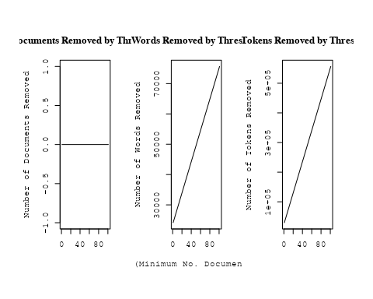

out_text <- prepDocuments(processed_text$documents, processed_text$vocab, processed_text$meta, lower.thresh = 15)

## Removing 70097 of 78993 terms (204129 of 5214438 tokens) due to frequency   
## Your corpus now has 63999 documents, 8896 terms and 5010309 tokens.

str(out_text$meta)

## 'data.frame': 63999 obs. of 39 variables:  
## $ concept_id : chr "https://openalex.org/C44870925" "https://openalex.org/C44870925" "https://openalex.org/C44870925" "https://openalex.org/C1276947" ...  
## $ work_id : chr "https://openalex.org/W1993867637" "https://openalex.org/W2022503540" "https://openalex.org/W2077626606" "https://openalex.org/W3104346433" ...  
## $ publication_year : int 2004 1991 2003 2003 2002 1999 2003 1997 2007 2002 ...  
## $ title : chr "KINEMATIC TREATMENT OF CORONAL MASS EJECTION EVOLUTION IN THE SOLAR WIND" "The imaging performance of the Hubble Space Telescope" "Numerical Simulations of Mass Outflows Driven from Accretion Disks by Radiation and Magnetic Forces" "The Origin of X-shaped Radio Galaxies: Clues from the Z-symmetric Secondary Lobes" ...  
## $ paperabstract : chr "We present a kinematic study of the evolution of coronal mass ejections (CMEs) in the solar wind. Specifically,"| __truncated__ "Problems with the HST instantaneous imaging performance and pointing performance are discussed. Optical tests h"| __truncated__ "We study the two-dimensional, time-dependent magnetohydrodynamics (MHD) of radiation-driven winds from luminous"| __truncated__ "Existing radio images of a few X-shaped radio galaxies reveal Z-symmetric morphologies in their weaker secondar"| __truncated__ ...  
## $ country : chr "US US US US" "US" "US" "IN US" ...  
## $ year_concept : chr "2004+https://openalex.org/C44870925" "1991+https://openalex.org/C44870925" "2003+https://openalex.org/C44870925" "2003+https://openalex.org/C1276947" ...  
## $ concatenated_title_abstract : chr "KINEMATIC TREATMENT OF CORONAL MASS EJECTION EVOLUTION IN THE SOLAR WIND We present a kinematic study of the ev"| __truncated__ "The imaging performance of the Hubble Space Telescope Problems with the HST instantaneous imaging performance a"| __truncated__ "Numerical Simulations of Mass Outflows Driven from Accretion Disks by Radiation and Magnetic Forces We study th"| __truncated__ "The Origin of X-shaped Radio Galaxies: Clues from the Z-symmetric Secondary Lobes Existing radio images of a fe"| __truncated__ ...  
## $ US : num 100 100 100 50 100 100 50 50 0 100 ...  
## $ IN : num 0 0 0 50 0 0 0 0 0 0 ...  
## $ DE : num 0 0 0 0 0 0 0 50 0 0 ...  
## $ CH : num 0 0 0 0 0 0 0 0 100 0 ...  
## $ GB : num 0 0 0 0 0 0 0 0 0 0 ...  
## $ CN : num 0 0 0 0 0 0 0 0 0 0 ...  
## $ FR : num 0 0 0 0 0 0 0 0 0 0 ...  
## $ IT : num 0 0 0 0 0 0 0 0 0 0 ...  
## $ RU : num 0 0 0 0 0 0 0 0 0 0 ...  
## $ CA : num 0 0 0 0 0 0 0 0 0 0 ...  
## $ NL : num 0 0 0 0 0 0 0 0 0 0 ...  
## $ AU : num 0 0 0 0 0 0 0 0 0 0 ...  
## $ JP : num 0 0 0 0 0 0 0 0 0 0 ...  
## $ ES : num 0 0 0 0 0 0 0 0 0 0 ...  
## $ IL : num 0 0 0 0 0 0 0 0 0 0 ...  
## $ Americas : num 0 0 0 0 0 0 0 0 0 0 ...  
## $ Europe : num 0 0 0 0 0 0 50 0 0 0 ...  
## $ Africa : num 0 0 0 0 0 0 0 0 0 0 ...  
## $ AsiaAndOceania : num 0 0 0 0 0 0 0 0 0 0 ...  
## $ pub_interval_2020_2022 : int 0 0 0 0 0 0 0 0 0 0 ...  
## $ pub_interval_2015_2019 : int 0 0 0 0 0 0 0 0 0 0 ...  
## $ pub_interval_2010_2014 : int 0 0 0 0 0 0 0 0 0 0 ...  
## $ pub_interval_2005_2009 : int 0 0 0 0 0 0 0 0 1 0 ...  
## $ pub_interval_2000_2004 : int 1 0 1 1 1 0 1 0 0 1 ...  
## $ pub_interval_1995_1999 : int 0 0 0 0 0 1 0 1 0 0 ...  
## $ pub_interval_1985_1994 : int 0 1 0 0 0 0 0 0 0 0 ...  
## $ pub_interval_1975_1984 : int 0 0 0 0 0 0 0 0 0 0 ...  
## $ pub_interval_1965_1974 : int 0 0 0 0 0 0 0 0 0 0 ...  
## $ pub_interval_1900_1964 : int 0 0 0 0 0 0 0 0 0 0 ...  
## $ pub_interval_1824_1899 : int 0 0 0 0 0 0 0 0 0 0 ...  
## $ original_concatenated_title_abstract: chr "KINEMATIC TREATMENT OF CORONAL MASS EJECTION EVOLUTION IN THE SOLAR WIND We present a kinematic study of the ev"| __truncated__ "The imaging performance of the Hubble Space Telescope Problems with the HST instantaneous imaging performance a"| __truncated__ "Numerical Simulations of Mass Outflows Driven from Accretion Disks by Radiation and Magnetic Forces We study th"| __truncated__ "The Origin of X-shaped Radio Galaxies: Clues from the Z-symmetric Secondary Lobes Existing radio images of a fe"| __truncated__ ...

# Initialize an empty formula string  
prevalence_formula_str <- "~"  
  
# Define the publication intervals  
pub_intervals <- c("pub_interval_2020_2022", "pub_interval_2015_2019", "pub_interval_2010_2014",   
 "pub_interval_2005_2009", "pub_interval_2000_2004", "pub_interval_1995_1999",  
 "pub_interval_1985_1994", "pub_interval_1975_1984", "pub_interval_1965_1974",  
 "pub_interval_1900_1964", "pub_interval_1824_1899")  
  
# Add each publication interval to the formula string  
for (interval in pub_intervals) {  
 # add an if statement to handle the first addition (without '+')  
 if (prevalence_formula_str == "~") {  
 prevalence_formula_str <- paste(prevalence_formula_str, interval)  
 } else {  
 prevalence_formula_str <- paste(prevalence_formula_str, "+", interval)  
 }  
}  
  
  
# Add each country variable to the formula string  
for (i in 9:27) {  
 prevalence_formula_str <- paste(prevalence_formula_str, "+", names(data)[i])  
}  
  
  
# Convert the string to a formula  
prevalence_formula <- as.formula(prevalence_formula_str)  
print(prevalence_formula)

## ~pub_interval_2020_2022 + pub_interval_2015_2019 + pub_interval_2010_2014 +   
## pub_interval_2005_2009 + pub_interval_2000_2004 + pub_interval_1995_1999 +   
## pub_interval_1985_1994 + pub_interval_1975_1984 + pub_interval_1965_1974 +   
## pub_interval_1900_1964 + pub_interval_1824_1899 + US + IN +   
## DE + CH + GB + CN + FR + IT + RU + CA + NL + AU + JP + ES +   
## IL + Americas + Europe + Africa + AsiaAndOceania

# Run STM model  
Research_topics <- stm(documents = out_text$documents,   
 vocab = out_text$vocab,   
 K = 45,   
 prevalence = prevalence_formula,   
 data = out_text$meta,   
 init.type = "Spectral",  
 max.em.its = 1000,  
 gamma.prior = 'L1')

## Beginning Spectral Initialization   
## Calculating the gram matrix...  
## Finding anchor words...  
## .............................................  
## Recovering initialization...  
## ........................................................................................  
## Initialization complete.  
## ....................................................................................................  
## Completed E-Step (84 seconds).   
## Completed M-Step (15 seconds).   
## Completing Iteration 1 (approx. per word bound = -7.035)   
## ....................................................................................................  
## Completed E-Step (90 seconds).   
## Completed M-Step (21 seconds).   
## Completing Iteration 2 (approx. per word bound = -6.813, relative change = 3.159e-02)   
## ....................................................................................................  
## Completed E-Step (82 seconds).   
## Completed M-Step (22 seconds).   
## Completing Iteration 3 (approx. per word bound = -6.743, relative change = 1.019e-02)   
## ....................................................................................................  
## Completed E-Step (73 seconds).   
## Completed M-Step (25 seconds).   
## Completing Iteration 4 (approx. per word bound = -6.712, relative change = 4.559e-03)   
## ....................................................................................................  
## Completed E-Step (65 seconds).   
## Completed M-Step (26 seconds).   
## Completing Iteration 5 (approx. per word bound = -6.696, relative change = 2.503e-03)   
## Topic 1: univers, gravit, hand, scienc, physic   
## Topic 2: review, studi, understand, discuss, observ   
## Topic 3: cosmic, ray, acceler, gamma, tev   
## Topic 4: dwarf, white, star, brown, mass   
## Topic 5: disk, accret, disc, rate, model   
## Topic 6: detect, wave, gravit, detector, signal   
## Topic 7: dynam, simul, system, numer, can   
## Topic 8: period, orbit, variabl, observ, variat   
## Topic 9: agn, activ, galaxi, nuclei, galact   
## Topic 10: star, neutron, rotat, mass, stellar   
## Topic 11: temperatur, model, spectra, line, light   
## Topic 12: interstellar, abund, line, medium, observ   
## Topic 13: lens, use, measur, redshift, paramet   
## Topic 14: halo, dark, matter, model, mass   
## Topic 15: supernova, explos, remnant, model, shock   
## Topic 16: flare, galact, sgr, event, center   
## Topic 17: x-ray, luminos, kev, hard, binari   
## Topic 18: mass, stellar, star, model, function   
## Topic 19: sourc, emiss, observ, x-ray, detect   
## Topic 20: cluster, galaxi, group, globular, ngc   
## Topic 21: radio, jet, galaxi, sourc, emiss   
## Topic 22: background, map, microwav, cosmic, reioniz   
## Topic 23: pulsar, puls, observ, millisecond, radio   
## Topic 24: magnet, field, polar, rotat, turbul   
## Topic 25: burst, energi, gamma-ray, grb, observ   
## Topic 26: supernova, type, progenitor, remnant, sne   
## Topic 27: planet, planetari, orbit, star, transit   
## Topic 28: wind, shock, outflow, shell, nebula   
## Topic 29: gas, cloud, molecular, region, format   
## Topic 30: galaxi, luminos, sampl, redshift, format   
## Topic 31: star, galaxi, format, metal, stellar   
## Topic 32: galaxi, spiral, bar, kinemat, rotat   
## Topic 33: line, emiss, neutrino, observ, electron   
## Topic 34: frequenc, oscil, mode, use, time   
## Topic 35: binari, system, veloc, star, mass   
## Topic 36: survey, data, sky, object, use   
## Topic 37: dust, emiss, infrar, grain, observ   
## Topic 38: hole, black, mass, supermass, galaxi   
## Topic 39: solar, coron, observ, sun, region   
## Topic 40: transit, line, maser, detect, observ   
## Topic 41: quasar, line, absorpt, redshift, emiss   
## Topic 42: distanc, star, use, magellan, lmc   
## Topic 43: imag, telescop, observ, use, space   
## Topic 44: astronom, one, star, observ, astronomi   
## Topic 45: observ, star, use, model, result   
## ....................................................................................................  
## Completed E-Step (61 seconds).   
## Completed M-Step (26 seconds).   
## Completing Iteration 6 (approx. per word bound = -6.686, relative change = 1.501e-03)   
## ....................................................................................................  
## Completed E-Step (58 seconds).   
## Completed M-Step (24 seconds).   
## Completing Iteration 7 (approx. per word bound = -6.679, relative change = 9.655e-04)   
## ....................................................................................................  
## Completed E-Step (57 seconds).   
## Completed M-Step (26 seconds).   
## Completing Iteration 8 (approx. per word bound = -6.675, relative change = 6.636e-04)   
## ....................................................................................................  
## Completed E-Step (55 seconds).   
## Completed M-Step (25 seconds).   
## Completing Iteration 9 (approx. per word bound = -6.671, relative change = 4.770e-04)   
## ....................................................................................................  
## Completed E-Step (54 seconds).   
## Completed M-Step (26 seconds).   
## Completing Iteration 10 (approx. per word bound = -6.669, relative change = 3.542e-04)   
## Topic 1: univers, year, earli, scienc, astronomi   
## Topic 2: physic, studi, discuss, understand, observ   
## Topic 3: cosmic, ray, energi, acceler, particl   
## Topic 4: dwarf, white, brown, nova, star   
## Topic 5: disk, accret, disc, rate, inner   
## Topic 6: detect, gravit, wave, will, search   
## Topic 7: dynam, simul, orbit, numer, effect   
## Topic 8: period, variabl, orbit, observ, variat   
## Topic 9: activ, agn, galaxi, nuclei, ngc   
## Topic 10: star, neutron, rotat, stellar, massiv   
## Topic 11: model, temperatur, spectra, light, effect   
## Topic 12: abund, interstellar, line, ratio, medium   
## Topic 13: measur, use, paramet, lens, method   
## Topic 14: halo, dark, matter, model, simul   
## Topic 15: supernova, explos, model, solar, isotop   
## Topic 16: flare, galact, event, center, sgr   
## Topic 17: x-ray, kev, luminos, hard, observ   
## Topic 18: mass, stellar, model, function, evolut   
## Topic 19: sourc, emiss, observ, detect, flux   
## Topic 20: cluster, group, galaxi, globular, ngc   
## Topic 21: radio, jet, sourc, emiss, galaxi   
## Topic 22: background, cosmic, microwav, map, spectrum   
## Topic 23: pulsar, puls, millisecond, time, observ   
## Topic 24: field, magnet, polar, rotat, turbul   
## Topic 25: burst, gamma-ray, energi, grb, observ   
## Topic 26: supernova, type, remnant, progenitor, sne   
## Topic 27: planet, planetari, orbit, transit, system   
## Topic 28: wind, shock, outflow, nebula, shell   
## Topic 29: gas, cloud, format, molecular, region   
## Topic 30: galaxi, luminos, redshift, format, sampl   
## Topic 31: star, metal, format, popul, galaxi   
## Topic 32: galaxi, spiral, veloc, kinemat, bar   
## Topic 33: line, emiss, electron, neutrino, observ   
## Topic 34: frequenc, oscil, mode, use, method   
## Topic 35: binari, system, veloc, companion, orbit   
## Topic 36: survey, sky, data, sampl, select   
## Topic 37: dust, infrar, emiss, grain, observ   
## Topic 38: hole, black, mass, merger, supermass   
## Topic 39: solar, observ, coron, sun, region   
## Topic 40: transit, line, maser, detect, observ   
## Topic 41: quasar, line, absorpt, redshift, emiss   
## Topic 42: distanc, star, use, magellan, mag   
## Topic 43: imag, telescop, space, observ, hubbl   
## Topic 44: astronom, one, paper, author, see   
## Topic 45: observ, result, present, show, use   
## ....................................................................................................  
## Completed E-Step (53 seconds).   
## Completed M-Step (25 seconds).   
## Completing Iteration 11 (approx. per word bound = -6.667, relative change = 2.670e-04)   
## ....................................................................................................  
## Completed E-Step (53 seconds).   
## Completed M-Step (24 seconds).   
## Completing Iteration 12 (approx. per word bound = -6.666, relative change = 2.163e-04)   
## ....................................................................................................  
## Completed E-Step (53 seconds).   
## Completed M-Step (25 seconds).   
## Completing Iteration 13 (approx. per word bound = -6.665, relative change = 1.695e-04)   
## ....................................................................................................  
## Completed E-Step (53 seconds).   
## Completed M-Step (25 seconds).   
## Completing Iteration 14 (approx. per word bound = -6.664, relative change = 1.447e-04)   
## ....................................................................................................  
## Completed E-Step (52 seconds).   
## Completed M-Step (25 seconds).   
## Completing Iteration 15 (approx. per word bound = -6.663, relative change = 1.180e-04)   
## Topic 1: univers, year, earli, scienc, astronomi   
## Topic 2: physic, studi, discuss, observ, understand   
## Topic 3: energi, ray, acceler, cosmic, particl   
## Topic 4: dwarf, white, brown, object, nova   
## Topic 5: disk, accret, disc, rate, inner   
## Topic 6: gravit, detect, wave, will, signal   
## Topic 7: simul, dynam, effect, numer, result   
## Topic 8: period, variabl, observ, variat, day   
## Topic 9: activ, agn, galaxi, nuclei, ngc   
## Topic 10: star, neutron, rotat, stellar, massiv   
## Topic 11: model, spectra, temperatur, spectral, fit   
## Topic 12: abund, interstellar, ratio, ioniz, line   
## Topic 13: measur, use, paramet, estim, lens   
## Topic 14: halo, dark, matter, model, simul   
## Topic 15: solar, element, explos, composit, supernova   
## Topic 16: flare, galact, event, center, sgr   
## Topic 17: x-ray, kev, observ, luminos, hard   
## Topic 18: mass, stellar, model, function, evolut   
## Topic 19: sourc, emiss, detect, observ, region   
## Topic 20: cluster, group, globular, galaxi, ngc   
## Topic 21: radio, jet, sourc, observ, emiss   
## Topic 22: background, cosmic, power, spectrum, scale   
## Topic 23: pulsar, puls, time, millisecond, observ   
## Topic 24: field, magnet, polar, rotat, turbul   
## Topic 25: burst, gamma-ray, grb, energi, observ   
## Topic 26: supernova, type, remnant, progenitor, sne   
## Topic 27: planet, orbit, planetari, transit, system   
## Topic 28: wind, shock, nebula, outflow, shell   
## Topic 29: gas, cloud, format, molecular, core   
## Topic 30: galaxi, luminos, redshift, format, sampl   
## Topic 31: star, metal, popul, format, age   
## Topic 32: galaxi, veloc, spiral, kinemat, bar   
## Topic 33: line, emiss, electron, plasma, temperatur   
## Topic 34: frequenc, mode, oscil, use, method   
## Topic 35: binari, system, orbit, companion, veloc   
## Topic 36: survey, sampl, sky, data, select   
## Topic 37: dust, infrar, emiss, grain, spitzer   
## Topic 38: hole, black, mass, merger, supermass   
## Topic 39: solar, observ, coron, activ, region   
## Topic 40: transit, line, maser, molecular, detect   
## Topic 41: line, quasar, absorpt, redshift, emiss   
## Topic 42: distanc, star, use, mag, magellan   
## Topic 43: imag, telescop, space, observ, hubbl   
## Topic 44: astronom, one, paper, see, author   
## Topic 45: observ, result, present, show, possibl   
## ....................................................................................................  
## Completed E-Step (52 seconds).   
## Completed M-Step (25 seconds).   
## Completing Iteration 16 (approx. per word bound = -6.662, relative change = 9.584e-05)   
## ....................................................................................................  
## Completed E-Step (52 seconds).   
## Completed M-Step (25 seconds).   
## Completing Iteration 17 (approx. per word bound = -6.662, relative change = 7.623e-05)   
## ....................................................................................................  
## Completed E-Step (53 seconds).   
## Completed M-Step (26 seconds).   
## Completing Iteration 18 (approx. per word bound = -6.661, relative change = 6.220e-05)   
## ....................................................................................................  
## Completed E-Step (52 seconds).   
## Completed M-Step (25 seconds).   
## Completing Iteration 19 (approx. per word bound = -6.661, relative change = 5.674e-05)   
## ....................................................................................................  
## Completed E-Step (52 seconds).   
## Completed M-Step (25 seconds).   
## Completing Iteration 20 (approx. per word bound = -6.661, relative change = 4.590e-05)   
## Topic 1: univers, year, earli, scienc, astronomi   
## Topic 2: physic, studi, discuss, observ, process   
## Topic 3: energi, ray, acceler, particl, cosmic   
## Topic 4: dwarf, white, brown, object, nova   
## Topic 5: disk, accret, disc, rate, inner   
## Topic 6: gravit, detect, wave, will, signal   
## Topic 7: simul, dynam, effect, numer, result   
## Topic 8: period, variabl, observ, variat, day   
## Topic 9: activ, agn, galaxi, nuclei, ngc   
## Topic 10: star, neutron, stellar, rotat, massiv   
## Topic 11: model, spectra, temperatur, spectral, fit   
## Topic 12: abund, interstellar, ratio, ioniz, densiti   
## Topic 13: measur, use, paramet, estim, data   
## Topic 14: halo, dark, matter, model, simul   
## Topic 15: element, solar, composit, mix, core   
## Topic 16: flare, galact, event, center, sgr   
## Topic 17: x-ray, kev, observ, luminos, hard   
## Topic 18: mass, stellar, function, model, evolut   
## Topic 19: sourc, emiss, detect, observ, region   
## Topic 20: cluster, group, globular, ngc, galaxi   
## Topic 21: radio, jet, observ, ghz, emiss   
## Topic 22: background, cosmic, power, scale, spectrum   
## Topic 23: pulsar, puls, neutron, time, millisecond   
## Topic 24: magnet, field, polar, rotat, turbul   
## Topic 25: burst, gamma-ray, grb, energi, observ   
## Topic 26: supernova, type, remnant, progenitor, sne   
## Topic 27: planet, orbit, planetari, transit, system   
## Topic 28: wind, shock, nebula, outflow, shell   
## Topic 29: gas, format, cloud, molecular, core   
## Topic 30: galaxi, redshift, luminos, format, sampl   
## Topic 31: metal, star, popul, age, format   
## Topic 32: galaxi, veloc, spiral, kinemat, bar   
## Topic 33: line, emiss, electron, temperatur, plasma   
## Topic 34: frequenc, mode, oscil, use, method   
## Topic 35: binari, system, orbit, companion, veloc   
## Topic 36: survey, sampl, sky, data, select   
## Topic 37: dust, infrar, emiss, grain, extinct   
## Topic 38: hole, black, mass, merger, supermass   
## Topic 39: solar, coron, observ, activ, region   
## Topic 40: transit, line, maser, molecular, detect   
## Topic 41: line, quasar, absorpt, redshift, emiss   
## Topic 42: distanc, star, mag, magellan, magnitud   
## Topic 43: imag, telescop, space, observ, hubbl   
## Topic 44: astronom, one, paper, refer, see   
## Topic 45: observ, result, possibl, present, show   
## ....................................................................................................  
## Completed E-Step (51 seconds).   
## Completed M-Step (26 seconds).   
## Completing Iteration 21 (approx. per word bound = -6.660, relative change = 4.254e-05)   
## ....................................................................................................  
## Completed E-Step (51 seconds).   
## Completed M-Step (26 seconds).   
## Completing Iteration 22 (approx. per word bound = -6.660, relative change = 4.328e-05)   
## ....................................................................................................  
## Completed E-Step (51 seconds).   
## Completed M-Step (25 seconds).   
## Completing Iteration 23 (approx. per word bound = -6.660, relative change = 3.260e-05)   
## ....................................................................................................  
## Completed E-Step (52 seconds).   
## Completed M-Step (25 seconds).   
## Completing Iteration 24 (approx. per word bound = -6.660, relative change = 3.575e-05)   
## ....................................................................................................  
## Completed E-Step (52 seconds).   
## Completed M-Step (25 seconds).   
## Completing Iteration 25 (approx. per word bound = -6.659, relative change = 3.608e-05)   
## Topic 1: univers, year, earli, scienc, astronomi   
## Topic 2: physic, observ, studi, discuss, process   
## Topic 3: energi, ray, acceler, particl, cosmic   
## Topic 4: dwarf, white, brown, object, nova   
## Topic 5: disk, accret, disc, rate, inner   
## Topic 6: gravit, detect, wave, will, neutrino   
## Topic 7: simul, dynam, effect, numer, result   
## Topic 8: period, variabl, observ, variat, light   
## Topic 9: activ, agn, galaxi, ngc, nuclei   
## Topic 10: star, stellar, massiv, rotat, giant   
## Topic 11: model, spectra, spectral, temperatur, fit   
## Topic 12: abund, interstellar, ratio, ioniz, densiti   
## Topic 13: measur, use, paramet, estim, data   
## Topic 14: halo, dark, matter, simul, model   
## Topic 15: element, solar, composit, mix, core   
## Topic 16: galact, flare, event, center, sgr   
## Topic 17: x-ray, kev, observ, luminos, hard   
## Topic 18: mass, stellar, function, evolut, model   
## Topic 19: sourc, emiss, detect, observ, region   
## Topic 20: cluster, group, globular, ngc, galaxi   
## Topic 21: radio, jet, ghz, observ, emiss   
## Topic 22: background, cosmic, power, scale, spectrum   
## Topic 23: pulsar, puls, neutron, time, millisecond   
## Topic 24: magnet, field, polar, rotat, turbul   
## Topic 25: burst, gamma-ray, grb, grbs, afterglow   
## Topic 26: supernova, type, remnant, progenitor, explos   
## Topic 27: planet, orbit, transit, planetari, system   
## Topic 28: wind, shock, nebula, outflow, shell   
## Topic 29: gas, format, cloud, core, molecular   
## Topic 30: galaxi, redshift, luminos, format, sampl   
## Topic 31: metal, popul, star, age, stellar   
## Topic 32: veloc, galaxi, spiral, kinemat, bar   
## Topic 33: emiss, line, electron, temperatur, radiat   
## Topic 34: frequenc, mode, oscil, use, method   
## Topic 35: binari, system, orbit, companion, veloc   
## Topic 36: survey, sampl, sky, data, select   
## Topic 37: dust, infrar, emiss, grain, extinct   
## Topic 38: hole, black, merger, mass, accret   
## Topic 39: solar, coron, observ, activ, region   
## Topic 40: transit, molecular, line, maser, toward   
## Topic 41: line, quasar, absorpt, redshift, width   
## Topic 42: distanc, mag, magnitud, photometri, magellan   
## Topic 43: imag, telescop, space, observ, hubbl   
## Topic 44: astronom, one, refer, paper, see   
## Topic 45: observ, possibl, result, may, present   
## ....................................................................................................  
## Completed E-Step (53 seconds).   
## Completed M-Step (25 seconds).   
## Completing Iteration 26 (approx. per word bound = -6.659, relative change = 3.417e-05)   
## ....................................................................................................  
## Completed E-Step (51 seconds).   
## Completed M-Step (25 seconds).   
## Completing Iteration 27 (approx. per word bound = -6.659, relative change = 3.834e-05)   
## ....................................................................................................  
## Completed E-Step (51 seconds).   
## Completed M-Step (25 seconds).   
## Completing Iteration 28 (approx. per word bound = -6.659, relative change = 4.057e-05)   
## ....................................................................................................  
## Completed E-Step (52 seconds).   
## Completed M-Step (26 seconds).   
## Completing Iteration 29 (approx. per word bound = -6.658, relative change = 3.681e-05)   
## ....................................................................................................  
## Completed E-Step (53 seconds).   
## Completed M-Step (25 seconds).   
## Completing Iteration 30 (approx. per word bound = -6.658, relative change = 3.719e-05)   
## Topic 1: univers, year, earli, scienc, astronomi   
## Topic 2: physic, studi, discuss, observ, provid   
## Topic 3: energi, ray, acceler, particl, cosmic   
## Topic 4: dwarf, white, object, brown, nova   
## Topic 5: disk, accret, disc, rate, inner   
## Topic 6: gravit, detect, wave, neutrino, will   
## Topic 7: simul, effect, dynam, numer, result   
## Topic 8: period, variabl, observ, variat, light   
## Topic 9: activ, agn, galaxi, ngc, nuclei   
## Topic 10: star, stellar, massiv, giant, rotat   
## Topic 11: model, spectra, spectral, observ, fit   
## Topic 12: abund, interstellar, ratio, measur, valu   
## Topic 13: measur, use, paramet, estim, data   
## Topic 14: halo, dark, matter, simul, model   
## Topic 15: element, solar, composit, mix, core   
## Topic 16: galact, event, flare, center, tidal   
## Topic 17: x-ray, kev, observ, luminos, hard   
## Topic 18: mass, stellar, function, evolut, distribut   
## Topic 19: sourc, emiss, detect, region, observ   
## Topic 20: cluster, group, globular, ngc, galaxi   
## Topic 21: radio, jet, observ, ghz, emiss   
## Topic 22: background, cosmic, power, scale, spectrum   
## Topic 23: pulsar, neutron, puls, time, millisecond   
## Topic 24: magnet, field, polar, rotat, turbul   
## Topic 25: burst, gamma-ray, grb, grbs, afterglow   
## Topic 26: supernova, type, remnant, progenitor, explos   
## Topic 27: planet, orbit, transit, planetari, system   
## Topic 28: wind, shock, nebula, outflow, shell   
## Topic 29: gas, format, cloud, core, cool   
## Topic 30: galaxi, redshift, format, luminos, sampl   
## Topic 31: metal, popul, age, stellar, star   
## Topic 32: veloc, galaxi, spiral, kinemat, bar   
## Topic 33: emiss, line, temperatur, electron, radiat   
## Topic 34: frequenc, mode, oscil, use, method   
## Topic 35: binari, system, orbit, companion, veloc   
## Topic 36: survey, sampl, sky, data, select   
## Topic 37: dust, infrar, emiss, grain, extinct   
## Topic 38: hole, black, merger, mass, accret   
## Topic 39: solar, flare, coron, observ, activ   
## Topic 40: molecular, transit, line, cloud, maser   
## Topic 41: line, quasar, absorpt, width, redshift   
## Topic 42: distanc, mag, photometri, magnitud, magellan   
## Topic 43: imag, telescop, space, observ, hubbl   
## Topic 44: astronom, one, refer, paper, author   
## Topic 45: observ, possibl, result, may, larg   
## ....................................................................................................  
## Completed E-Step (54 seconds).   
## Completed M-Step (26 seconds).   
## Completing Iteration 31 (approx. per word bound = -6.658, relative change = 3.254e-05)   
## ....................................................................................................  
## Completed E-Step (52 seconds).   
## Completed M-Step (25 seconds).   
## Completing Iteration 32 (approx. per word bound = -6.658, relative change = 3.727e-05)   
## ....................................................................................................  
## Completed E-Step (53 seconds).   
## Completed M-Step (26 seconds).   
## Completing Iteration 33 (approx. per word bound = -6.658, relative change = 3.587e-05)   
## ....................................................................................................  
## Completed E-Step (55 seconds).   
## Completed M-Step (26 seconds).   
## Completing Iteration 34 (approx. per word bound = -6.657, relative change = 3.498e-05)   
## ....................................................................................................  
## Completed E-Step (56 seconds).   
## Completed M-Step (26 seconds).   
## Completing Iteration 35 (approx. per word bound = -6.657, relative change = 3.604e-05)   
## Topic 1: univers, year, earli, scienc, astronomi   
## Topic 2: physic, studi, discuss, observ, provid   
## Topic 3: energi, ray, acceler, particl, cosmic   
## Topic 4: dwarf, white, brown, object, nova   
## Topic 5: disk, accret, disc, rate, inner   
## Topic 6: gravit, detect, wave, neutrino, will   
## Topic 7: simul, effect, dynam, numer, result   
## Topic 8: period, variabl, observ, light, variat   
## Topic 9: activ, agn, galaxi, ngc, nuclei   
## Topic 10: star, stellar, massiv, giant, rotat   
## Topic 11: model, spectra, observ, spectral, predict   
## Topic 12: abund, interstellar, ratio, measur, valu   
## Topic 13: measur, use, paramet, estim, data   
## Topic 14: halo, dark, matter, simul, model   
## Topic 15: element, solar, composit, core, mix   
## Topic 16: galact, way, event, center, milki   
## Topic 17: x-ray, kev, observ, luminos, hard   
## Topic 18: mass, stellar, function, evolut, distribut   
## Topic 19: sourc, detect, emiss, region, object   
## Topic 20: cluster, group, globular, ngc, galaxi   
## Topic 21: radio, jet, observ, ghz, emiss   
## Topic 22: background, cosmic, power, scale, cosmolog   
## Topic 23: pulsar, neutron, puls, time, millisecond   
## Topic 24: magnet, field, polar, rotat, turbul   
## Topic 25: burst, gamma-ray, grb, grbs, afterglow   
## Topic 26: supernova, type, remnant, progenitor, explos   
## Topic 27: planet, orbit, transit, planetari, system   
## Topic 28: wind, shock, nebula, outflow, shell   
## Topic 29: gas, format, cloud, core, form   
## Topic 30: galaxi, redshift, format, luminos, local   
## Topic 31: metal, popul, age, stellar, format   
## Topic 32: veloc, galaxi, spiral, kinemat, bar   
## Topic 33: emiss, line, temperatur, radiat, thermal   
## Topic 34: frequenc, mode, oscil, use, method   
## Topic 35: binari, system, orbit, companion, veloc   
## Topic 36: survey, sampl, sky, data, select   
## Topic 37: dust, infrar, emiss, grain, extinct   
## Topic 38: hole, black, merger, mass, accret   
## Topic 39: solar, flare, coron, observ, activ   
## Topic 40: molecular, cloud, line, maser, observ   
## Topic 41: line, quasar, absorpt, width, emiss   
## Topic 42: distanc, mag, photometri, magnitud, magellan   
## Topic 43: imag, telescop, space, observ, hubbl   
## Topic 44: astronom, one, refer, paper, author   
## Topic 45: observ, possibl, shown, may, result   
## ....................................................................................................  
## Completed E-Step (54 seconds).   
## Completed M-Step (27 seconds).   
## Completing Iteration 36 (approx. per word bound = -6.657, relative change = 3.288e-05)   
## ....................................................................................................  
## Completed E-Step (56 seconds).   
## Completed M-Step (26 seconds).   
## Completing Iteration 37 (approx. per word bound = -6.657, relative change = 2.939e-05)   
## ....................................................................................................  
## Completed E-Step (57 seconds).   
## Completed M-Step (26 seconds).   
## Completing Iteration 38 (approx. per word bound = -6.656, relative change = 2.819e-05)   
## ....................................................................................................  
## Completed E-Step (59 seconds).   
## Completed M-Step (26 seconds).   
## Completing Iteration 39 (approx. per word bound = -6.656, relative change = 2.536e-05)   
## ....................................................................................................  
## Completed E-Step (56 seconds).   
## Completed M-Step (27 seconds).   
## Completing Iteration 40 (approx. per word bound = -6.656, relative change = 2.759e-05)   
## Topic 1: univers, year, earli, scienc, astronomi   
## Topic 2: physic, studi, discuss, observ, provid   
## Topic 3: energi, ray, acceler, particl, cosmic   
## Topic 4: dwarf, white, brown, object, nova   
## Topic 5: disk, accret, disc, rate, inner   
## Topic 6: gravit, detect, wave, neutrino, will   
## Topic 7: simul, effect, numer, dynam, result   
## Topic 8: period, variabl, observ, light, variat   
## Topic 9: activ, agn, galaxi, ngc, nuclei   
## Topic 10: star, stellar, massiv, giant, rotat   
## Topic 11: model, observ, predict, spectra, fit   
## Topic 12: abund, interstellar, ratio, measur, valu   
## Topic 13: measur, use, paramet, estim, method   
## Topic 14: halo, dark, matter, simul, model   
## Topic 15: element, solar, composit, core, mix   
## Topic 16: galact, way, milki, center, tidal   
## Topic 17: x-ray, kev, observ, hard, luminos   
## Topic 18: mass, stellar, function, distribut, evolut   
## Topic 19: sourc, detect, emiss, object, region   
## Topic 20: cluster, group, globular, ngc, galaxi   
## Topic 21: radio, jet, observ, emiss, ghz   
## Topic 22: background, cosmic, power, scale, cosmolog   
## Topic 23: pulsar, neutron, puls, time, millisecond   
## Topic 24: magnet, field, polar, rotat, turbul   
## Topic 25: burst, gamma-ray, grb, grbs, afterglow   
## Topic 26: supernova, type, remnant, progenitor, explos   
## Topic 27: planet, orbit, transit, planetari, system   
## Topic 28: wind, shock, nebula, outflow, shell   
## Topic 29: gas, format, core, cloud, form   
## Topic 30: galaxi, redshift, format, luminos, local   
## Topic 31: metal, popul, age, stellar, format   
## Topic 32: veloc, galaxi, spiral, kinemat, bar   
## Topic 33: emiss, line, temperatur, radiat, thermal   
## Topic 34: frequenc, mode, oscil, use, method   
## Topic 35: binari, system, orbit, companion, veloc   
## Topic 36: survey, sampl, sky, data, select   
## Topic 37: dust, infrar, emiss, grain, extinct   
## Topic 38: hole, black, merger, accret, supermass   
## Topic 39: solar, flare, coron, observ, activ   
## Topic 40: cloud, molecular, line, maser, observ   
## Topic 41: line, quasar, absorpt, spectra, width   
## Topic 42: distanc, mag, photometri, magnitud, magellan   
## Topic 43: imag, telescop, space, observ, hubbl   
## Topic 44: astronom, one, refer, research, paper   
## Topic 45: possibl, observ, shown, may, exist   
## ....................................................................................................  
## Completed E-Step (59 seconds).   
## Completed M-Step (26 seconds).   
## Completing Iteration 41 (approx. per word bound = -6.656, relative change = 2.426e-05)   
## ....................................................................................................  
## Completed E-Step (60 seconds).   
## Completed M-Step (26 seconds).   
## Completing Iteration 42 (approx. per word bound = -6.656, relative change = 2.441e-05)   
## ....................................................................................................  
## Completed E-Step (61 seconds).   
## Completed M-Step (26 seconds).   
## Completing Iteration 43 (approx. per word bound = -6.656, relative change = 1.956e-05)   
## ....................................................................................................  
## Completed E-Step (61 seconds).   
## Completed M-Step (25 seconds).   
## Completing Iteration 44 (approx. per word bound = -6.656, relative change = 1.494e-05)   
## ....................................................................................................  
## Completed E-Step (62 seconds).   
## Completed M-Step (25 seconds).   
## Completing Iteration 45 (approx. per word bound = -6.655, relative change = 1.746e-05)   
## Topic 1: univers, year, earli, scienc, astronomi   
## Topic 2: physic, studi, discuss, observ, provid   
## Topic 3: energi, ray, acceler, particl, cosmic   
## Topic 4: dwarf, white, brown, object, nova   
## Topic 5: disk, accret, disc, rate, inner   
## Topic 6: gravit, detect, neutrino, event, wave   
## Topic 7: simul, effect, numer, result, dynam   
## Topic 8: period, variabl, light, observ, variat   
## Topic 9: activ, agn, galaxi, nuclei, ngc   
## Topic 10: star, stellar, massiv, giant, sequenc   
## Topic 11: model, observ, predict, use, fit   
## Topic 12: abund, ratio, interstellar, measur, valu   
## Topic 13: measur, use, paramet, estim, method   
## Topic 14: halo, dark, matter, simul, cosmolog   
## Topic 15: element, solar, composit, core, helium   
## Topic 16: galact, way, milki, center, tidal   
## Topic 17: x-ray, kev, observ, hard, luminos   
## Topic 18: mass, stellar, function, distribut, per   
## Topic 19: sourc, detect, emiss, object, optic   
## Topic 20: cluster, group, globular, ngc, system   
## Topic 21: radio, jet, emiss, observ, ghz   
## Topic 22: background, cosmic, scale, power, cosmolog   
## Topic 23: pulsar, neutron, puls, time, millisecond   
## Topic 24: magnet, field, polar, rotat, turbul   
## Topic 25: burst, gamma-ray, grb, grbs, afterglow   
## Topic 26: supernova, type, remnant, progenitor, explos   
## Topic 27: planet, orbit, transit, planetari, system   
## Topic 28: wind, shock, nebula, outflow, shell   
## Topic 29: gas, format, core, form, cloud   
## Topic 30: galaxi, redshift, format, luminos, local   
## Topic 31: metal, popul, age, stellar, format   
## Topic 32: veloc, galaxi, spiral, kinemat, rotat   
## Topic 33: emiss, temperatur, line, radiat, thermal   
## Topic 34: frequenc, mode, oscil, use, method   
## Topic 35: binari, system, orbit, companion, close   
## Topic 36: survey, sampl, sky, data, select   
## Topic 37: dust, infrar, emiss, grain, extinct   
## Topic 38: hole, black, merger, accret, supermass   
## Topic 39: solar, flare, coron, observ, activ   
## Topic 40: cloud, molecular, region, line, maser   
## Topic 41: line, quasar, absorpt, spectra, width   
## Topic 42: distanc, mag, photometri, magnitud, magellan   
## Topic 43: imag, telescop, space, observ, hubbl   
## Topic 44: astronom, one, refer, research, paper   
## Topic 45: possibl, observ, exist, shown, may   
## ....................................................................................................  
## Completed E-Step (63 seconds).   
## Completed M-Step (25 seconds).   
## Completing Iteration 46 (approx. per word bound = -6.655, relative change = 1.311e-05)   
## ....................................................................................................  
## Completed E-Step (63 seconds).   
## Completed M-Step (26 seconds).   
## Completing Iteration 47 (approx. per word bound = -6.655, relative change = 1.446e-05)   
## ....................................................................................................  
## Completed E-Step (64 seconds).   
## Completed M-Step (26 seconds).   
## Completing Iteration 48 (approx. per word bound = -6.655, relative change = 1.493e-05)   
## ....................................................................................................  
## Completed E-Step (65 seconds).   
## Completed M-Step (25 seconds).   
## Model Converged

# Plot the STM model summary  
plot(Research_topics, type = "summary", xlim = c(0, 0.3))

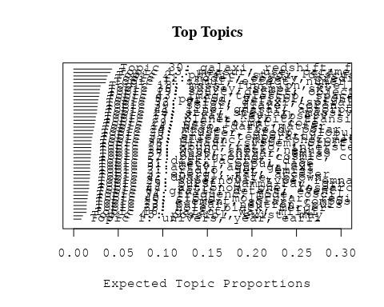

# Print the top 10 labels for each topic  
topic_labels <- labelTopics(Research_topics, n=10)  
print(topic_labels)

## Topic 1 Top Words:  
## Highest Prob: univers, year, earli, scienc, astronomi, cosmic, million, physic, billion, distant   
## FREX: depart, usa, billion, bang, institut, big, itali, string, germani, california   
## Lift: fisica, germani, instituto, astronomico, cnrs, depart, garch, greenbelt, inaf, kavli   
## Score: univers, scienc, astronomi, institut, billion, bang, year, big, cosmic, usa   
## Topic 2 Top Words:  
## Highest Prob: physic, studi, discuss, observ, provid, properti, process, import, new, evolut   
## FREX: understand, review, focus, progress, import, discuss, role, physic, question, address   
## Lift: peer, unansw, gmbh, kgaa, verlag, weinheim, wiley-vch, review, emphasi, insight   
## Score: review, understand, physic, astrophys, evolut, role, discuss, process, import, futur   
## Topic 3 Top Words:  
## Highest Prob: energi, ray, acceler, particl, cosmic, electron, spectrum, tev, gamma, proton   
## FREX: tev, cosmic-ray, ray, positron, gev, acceler, proton, mev, hess, annihil   
## Lift: c-ray, pevatron, ultrahigh-energi, air-show, cerenkov, galprop, gzk, hillier, pev, tev-   
## Score: ray, tev, acceler, cosmic, particl, energi, electron, proton, cosmic-ray, gev   
## Topic 4 Top Words:  
## Highest Prob: dwarf, white, brown, object, nova, type, member, spectral, young, candid   
## FREX: brown, dwarf, white, nova, pleiad, substellar, hyad, teff, ultracool, wds   
## Lift: bergeron, burgass, denis-p, mid-typ, late-m, baraff, brown, deuterium-burn, late-t, massw   
## Score: dwarf, white, brown, nova, pleiad, substellar, member, teff, hyad, ultracool   
## Topic 5 Top Words:  
## Highest Prob: disk, accret, disc, rate, inner, flow, thick, around, radius, outer   
## FREX: disc, disk, accret, herbig, thick, tauri, protoplanetari, warp, thin, tau   
## Lift: shakura-sunyaev, signi, cttss, proplyd, wttss, adaf, ctts, bardeen-petterson, haeb, star-disk   
## Score: disk, accret, disc, tauri, protoplanetari, inner, circumstellar, flow, herbig, warp   
## Topic 6 Top Words:  
## Highest Prob: gravit, detect, event, neutrino, wave, will, microlens, signal, search, detector   
## FREX: neutrino, gravitational-wav, microlens, ligo, sim, axion, detector, gravit, laser, quark   
## Lift: lhc, third-gener, antar, axion, graviton, ligo, nanohertz, pta, ptas, cern   
## Score: neutrino, gravit, microlens, wave, event, detector, gravitational-wav, signal, ligo, neutron   
## Topic 7 Top Words:  
## Highest Prob: simul, effect, numer, result, evolut, dynam, instabl, equat, initi, momentum   
## FREX: equat, instabl, forc, analyt, momentum, numer, solut, perturb, stabil, hydrodynam   
## Lift: amend, polytrop, arrokoth, chao, barotrop, indefinit, shock-captur, inviscid, many-bodi, two-fluid   
## Score: simul, instabl, momentum, equat, perturb, hydrodynam, torqu, particl, analyt, wave   
## Topic 8 Top Words:  
## Highest Prob: period, variabl, light, observ, variat, curv, time, day, chang, pulsat   
## FREX: variabl, cataclysm, pulsat, period, variat, monitor, cvs, day, spot, modul   
## Lift: intranight, multiperiod, sextanti, superhump, vltfor, semiregular, exor, palla, bright-spot, periodogram   
## Score: variabl, period, pulsat, curv, eclips, outburst, day, cataclysm, variat, monitor   
## Topic 9 Top Words:  
## Highest Prob: activ, agn, galaxi, nuclei, ngc, galact, starburst, nucleus, luminos, seyfert   
## FREX: agn, seyfert, nucleus, liner, starburst, ulirg, obscur, nuclei, circumnuclear, activ   
## Lift: blss, wwwblackwell-synergycom, liner, agn, agn-lik, linerh, llagn, nls, non-agn, ulig   
## Score: agn, seyfert, starburst, nuclei, galaxi, ngc, nucleus, activ, nuclear, ulirg   
## Topic 10 Top Words:  
## Highest Prob: star, stellar, massiv, giant, sequenc, evolv, rotat, young, red, low-mass   
## FREX: star, sequenc, main-sequ, supergi, evolv, branch, stellar, giant, massiv, agb   
## Lift: tres, deconfin, hyperon, ehb, early-b, post-asymptot, star, b-type, o-typ, b-b   
## Score: star, stellar, massiv, giant, agb, main-sequ, branch, supergi, rotat, envelop   
## Topic 11 Top Words:  
## Highest Prob: model, observ, predict, use, fit, effect, spectra, paramet, calcul, data   
## FREX: model, fit, reproduc, predict, agreement, simpl, good, calcul, opac, match   
## Lift: line-blanket, predecessor, nlte, wm-basic, cmfgen, tlusti, kurucz, blanket, macroturbul, marc   
## Score: model, fit, spectra, atmospher, spectral, predict, paramet, opac, reproduc, calcul   
## Topic 12 Top Words:  
## Highest Prob: abund, ratio, interstellar, measur, valu, hydrogen, densiti, line, medium, deriv   
## FREX: sup, abund, interstellar, oxygen, atom, deplet, fuse, hydrogen, approx, nitrogen   
## Lift: arh, nitrogen--oxygen, dib, geball, lic, lism, ssup, underabund, heh, nsub   
## Score: abund, interstellar, oxygen, ioniz, sup, hydrogen, atom, element, ratio, line   
## Topic 13 Top Words:  
## Highest Prob: measur, use, paramet, estim, method, data, lens, determin, can, statist   
## FREX: lens, len, error, systemat, statist, method, bias, uncertainti, paramet, measur   
## Lift: essenc, flexion, len, jvas, two-imag, shapelet, magnif, four-imag, wigglez, maximum-likelihood   
## Score: lens, len, method, error, measur, paramet, bias, uncertainti, function, statist   
## Topic 14 Top Words:  
## Highest Prob: halo, dark, matter, simul, cosmolog, galaxi, densiti, model, satellit, baryon   
## FREX: subhalo, dark, halo, cdm, matter, baryon, n-bodi, void, λcdm, substructur   
## Lift: navarro-frenk-whit, bullock, fine-tun, mmin, n-bodygasdynam, press–schecht, tormen, way-siz, wdm, hod   
## Score: halo, dark, matter, subhalo, cosmolog, cdm, baryon, simul, n-bodi, galaxi   
## Topic 15 Top Words:  
## Highest Prob: element, solar, composit, core, helium, abund, mix, chemic, isotop, materi   
## FREX: meteorit, isotop, r-process, chondrit, nucleosynthesi, burn, reaction, ignit, s-process, chondrul   
## Lift: intershel, presolar, alal, chondrul, half-lif, radionuclid, spherul, aqueous, beth, chondrit   
## Score: isotop, meteorit, r-process, nucleosynthesi, element, reaction, helium, burn, abund, grain   
## Topic 16 Top Words:  
## Highest Prob: galact, way, milki, center, tidal, plane, sgr, stream, disrupt, tail   
## FREX: milki, stream, way, sgr, disrupt, plane, tail, galact, sagittarius, tidal   
## Lift: tde, french, tdes, coup, perigalacticon, pal, stream, way’, milki, disrupt   
## Score: galact, sgr, milki, tidal, disrupt, stream, way, center, sagittarius, plane   
## Topic 17 Top Words:  
## Highest Prob: x-ray, kev, observ, hard, luminos, chandra, spectral, soft, erg, state   
## FREX: kev, x-ray, xmm-newton, chandra, hard, soft, asca, rosat, igr, rxte   
## Lift: hard-band, hext, softest, una, xlf, xrb, igr, lowhard, hmxbs, xmm-newton   
## Score: x-ray, kev, chandra, soft, hard, erg, xmm-newton, xte, ulx, rosat   
## Topic 18 Top Words:  
## Highest Prob: mass, function, stellar, per, distribut, rate, evolut, fraction, luminos, cent   
## FREX: mass, function, per, imf, cent, initi, fraction, dot, stellar, total   
## Lift: semiconvect, onc, imf, top-heavi, birthlin, salpet, mcircl, cmf, logm, mto   
## Score: mass, function, imf, stellar, luminos, cent, per, evolut, initi, rate   
## Topic 19 Top Words:  
## Highest Prob: sourc, detect, object, emiss, optic, region, compact, observ, associ, limit   
## FREX: sourc, counterpart, compact, coincid, detect, class, unresolv, object, identif, posit   
## Lift: son, beam−, sourc, counterpart, nondetect, point-lik, ibisisgri, uhuru, opticalnir, coincid   
## Score: sourc, detect, emiss, optic, object, compact, counterpart, mji, flux, region   
## Topic 20 Top Words:  
## Highest Prob: cluster, group, globular, ngc, system, distribut, core, galaxi, gcs, central   
## FREX: cluster, globular, gcs, intraclust, group, abel, virgo, bcgs, fornax, rich   
## Lift: bss, bsss, hcg, madrid, bcg, icl, vcc, hickson, bcgs, cluster   
## Score: cluster, globular, ngc, group, gcs, intraclust, virgo, abel, fornax, bcgs   
## Topic 21 Top Words:  
## Highest Prob: radio, jet, emiss, observ, ghz, relativist, array, synchrotron, power, vla   
## FREX: vla, radio, vlba, jet, lac, vlbi, ghz, flat-spectrum, frb, baselin   
## Lift: jet–cloud, edge-brighten, fanaroff-riley, core-jet, counterjet, double-doubl, hbls, johnston, peaked-spectrum, twin-jet   
## Score: radio, jet, ghz, vla, synchrotron, relativist, blazar, emiss, vlbi, mhz   
## Topic 22 Top Words:  
## Highest Prob: background, cosmic, cosmolog, scale, power, redshift, spectrum, microwav, reioniz, fluctuat   
## FREX: cmb, reioniz, wmap, igm, anisotropi, microwav, background, intergalact, non-gaussian, fluctuat   
## Lift: acbar, cmbr, e-mod, genus, b-mode, bispectrum, cbi, dmr, eor, fnl   
## Score: reioniz, cmb, background, microwav, cosmic, cosmolog, wmap, igm, anisotropi, redshift   
## Topic 23 Top Words:  
## Highest Prob: pulsar, neutron, puls, time, millisecond, spin, psr, observ, magnetar, period   
## FREX: pulsar, millisecond, psr, glitch, puls, vela, spin-, magnetar, axp, msps   
## Lift: axp, israel, rotation-pow, conal, glitch, msps, psrs, pulsar’, lyne, millisecond   
## Score: pulsar, neutron, puls, psr, millisecond, glitch, magnetar, spin-, crab, spin   
## Topic 24 Top Words:  
## Highest Prob: magnet, field, polar, rotat, turbul, strength, strong, surfac, flow, plasma   
## FREX: dynamo, magnet, mhd, magnetohydrodynam, polar, alfven, toroid, field, electr, turbul   
## Lift: espadon, mcvs, microgauss, dynamo, poloid, narval, weibel, larmor, prandtl, ohmic   
## Score: magnet, field, polar, turbul, mhd, dynamo, rotat, magnetohydrodynam, magnetospher, convect   
## Topic 25 Top Words:  
## Highest Prob: burst, gamma-ray, grb, grbs, afterglow, emiss, observ, energi, time, relativist   
## FREX: grb, grbs, afterglow, burst, prompt, gamma-ray, bats, firebal, swift, fluenc   
## Lift: epeak, ipn, short-hard, afterglow, bats, circumburst, eiso, forward-shock, ghirlanda, grb   
## Score: burst, grb, gamma-ray, afterglow, grbs, swift, bats, γray, firebal, relativist   
## Topic 26 Top Words:  
## Highest Prob: supernova, type, remnant, progenitor, explos, sne, ejecta, light, snr, observ   
## FREX: sne, snr, supernova, snrs, core-collaps, progenitor, explos, remnant, ejecta, csm   
## Lift: osservatorio, usepackagemathrsf, documentclassaastex, iib, pagestyleempti, usepackageamsfont, usepackageamssymb, usepackagebm, usepackagepifont, usepackagestmaryrd   
## Score: supernova, sne, explos, remnant, progenitor, ejecta, type, snr, snrs, core-collaps   
## Topic 27 Top Words:  
## Highest Prob: planet, orbit, transit, planetari, system, atmospher, jupit, asteroid, exoplanet, solar   
## FREX: planet, jupit, exoplanet, extrasolar, habit, neptun, close-, saturn, planetesim, belt   
## Lift: exoplanetari, giant-planet, mass-period, xo-, close-, earth-lik, exoplanet, habit, jupiter-mass, biomark   
## Score: planet, orbit, exoplanet, jupit, extrasolar, asteroid, planetesim, planetari, eccentr, habit   
## Topic 28 Top Words:  
## Highest Prob: wind, shock, nebula, outflow, shell, structur, planetari, central, veloc, interact   
## FREX: wind, outflow, nebula, bipolar, shock, front, bubbl, caviti, pne, shell   
## Lift: avec, bow, homunculus, point-symmetr, pour, ppn, pre-planetari, une, sont, waist   
## Score: shock, wind, outflow, nebula, shell, planetari, bubbl, bipolar, filament, pne   
## Topic 29 Top Words:  
## Highest Prob: gas, format, core, form, cool, cloud, densiti, feedback, region, medium   
## FREX: gas, feedback, fragment, clump, format, gaseous, gmcs, pressur, cool, regul   
## Lift: gmcs, bonnor-ebert, eleph, pre-galact, lyman-wern, lyman–wern, nh-, hypercompact, cgm, kennicutt–schmidt   
## Score: gas, format, feedback, cloud, core, cool, turbul, clump, fragment, molecular   
## Topic 30 Top Words:  
## Highest Prob: galaxi, redshift, format, luminos, local, sampl, relat, evolut, densiti, star-form   
## FREX: sfr, early-typ, galaxi, smgs, sfrs, etg, rest-fram, lbgs, star-form, redshift   
## Lift: colour–dens, ssfr, sfrs, bzk, drgs, etg, sfrm, vlg, sfr, udf   
## Score: galaxi, redshift, format, luminos, sfr, star-form, early-typ, ellipt, rest-fram, merger   
## Topic 31 Top Words:  
## Highest Prob: metal, popul, age, stellar, format, gyr, old, histori, myr, metal-poor   
## FREX: metal-poor, metal, metal-rich, feh, gyr, age, younger, old, popul, older   
## Lift: cafe, hamburgeso, nafe, ssps, lickid, ssp-equival, αenhanc, αfe, age-metal, age–metal   
## Score: metal, age, feh, metal-poor, gyr, popul, stellar, metal-rich, myr, format   
## Topic 32 Top Words:  
## Highest Prob: veloc, galaxi, spiral, kinemat, rotat, bar, structur, dispers, radial, profil   
## FREX: bar, kinemat, spiral, arm, gradient, dispers, veloc, ring, bulg, isophot   
## Lift: atlasd, boxypeanut, lopsided, minor-axi, nuker, sbb, bulgedisk, gauss-hermit, lopsid, helmi   
## Score: spiral, bar, veloc, kinemat, galaxi, bulg, rotat, arm, disk, kpc   
## Topic 33 Top Words:  
## Highest Prob: emiss, temperatur, line, radiat, thermal, ioniz, heat, hot, region, electron   
## FREX: nontherm, thermal, forbidden, heat, temperatur, fluoresc, hot, plasma, ioniz, recombin   
## Lift: becker, density-sensit, helium-lik, l-shell, h-like, forbidden, hetg, chianti, neupert, xxiv   
## Score: emiss, temperatur, ioniz, line, plasma, thermal, heat, electron, radiat, nontherm   
## Topic 34 Top Words:  
## Highest Prob: frequenc, mode, oscil, use, method, analysi, simul, nois, mont, carlo   
## FREX: oscil, mode, mont, carlo, qpos, qpo, harmon, algorithm, nois, frequenc   
## Lift: rfi, low-degre, high-perform, μhz, qpos, p-mode, python, kilohertz, oscil, g-mode   
## Score: oscil, frequenc, mode, qpo, qpos, nois, algorithm, quasi-period, harmon, p-mode   
## Topic 35 Top Words:  
## Highest Prob: binari, system, orbit, companion, close, separ, veloc, secondari, primari, compon   
## FREX: binari, companion, donor, secondari, circumbinari, system, orbit, primari, tripl, separ   
## Lift: sine-curv, colliding-wind, duquennoy, post-common-envelop, tomogram, hvss, eggleton, algol, semidetach, double-lin   
## Score: binari, orbit, companion, system, eccentr, eclips, secondari, donor, period, veloc   
## Topic 36 Top Words:  
## Highest Prob: survey, sampl, sky, data, select, sdss, catalog, use, digit, spectroscop   
## FREX: survey, digit, sdss, sloan, catalog, select, deg, sky, catalogu, sampl   
## Lift: mnras, xmm-lss, subaruxmm-newton, sextractor, ukidss, cross-identif, wfcam, zphot, elg, hipass   
## Score: survey, sdss, sloan, digit, catalog, sky, sampl, photometr, catalogu, select   
## Topic 37 Top Words:  
## Highest Prob: dust, infrar, emiss, grain, extinct, wavelength, spitzer, comet, band, observ   
## FREX: dust, spitzer, pah, mid-infrar, infrar, irac, far-infrar, ira, fir, comet   
## Lift: pschwassmann-wachmann, apr, comet’, dust--met, lirl, pchuryumov-gerasimenko, phalley, polycycl, ptempel, aromat   
## Score: dust, infrar, grain, comet, spitzer, ira, extinct, pah, far-infrar, mid-infrar   
## Topic 38 Top Words:  
## Highest Prob: hole, black, merger, accret, supermass, mass, massiv, spin, central, merg   
## FREX: supermass, black, hole, bhs, mbh, smbh, smbhs, imbh, merger, stellar-mass   
## Lift: bhs, mbhσ, smbhs, black, hole, hole-bulg, imbh, mbhs, m•σ, supermass   
## Score: black, hole, supermass, merger, accret, mbh, bhs, smbh, imbh, smbhs   
## Topic 39 Top Words:  
## Highest Prob: solar, flare, coron, observ, activ, region, flux, event, corona, sun   
## FREX: cmes, cme, coron, heliospher, loop, flare, rope, sunspot, soho, corona   
## Lift: geospac, substorm, eit, facula, mdi, ribbon, aia, bbso, bipol, c-class   
## Score: flare, coron, solar, cmes, cme, sunspot, heliospher, loop, corona, reconnect   
## Topic 40 Top Words:  
## Highest Prob: cloud, molecular, region, maser, observ, line, toward, emiss, detect, molecul   
## FREX: maser, molecul, hcn, methanol, hco, molecular, sio, orion, chemistri, cloud   
## Lift: deuter, ground-stat, hydroxyl, isotopologu, methyl, chcn, choh, hcn, hco, hcooch   
## Score: molecular, cloud, maser, molecul, water, hcn, methanol, ice, hco, orion   
## Topic 41 Top Words:  
## Highest Prob: line, quasar, absorpt, spectra, emiss, width, broad, continuum, redshift, lyα   
## FREX: lyα, qso, absorpt, quasar, qsos, width, broad, balmer, absorb, equival   
## Lift: non-bal, dla, dlas, lbqs, baldwin, balqso, belr, boroson, mgii, smc-like   
## Score: quasar, line, absorpt, lyα, qsos, redshift, qso, continuum, spectra, width   
## Topic 42 Top Words:  
## Highest Prob: distanc, mag, photometri, magnitud, magellan, color, use, relat, lmc, determin   
## FREX: lmc, cepheid, magellan, smc, parallax, modulus, absolut, lyra, mag, hipparco   
## Lift: ogle-ii, araucaria, baade-wesselink, cepheid, fullparti, michigan-dartmouth-mit, modulus, period-amplitud, period–luminos, trgb   
## Score: cepheid, lmc, magellan, parallax, mag, photometri, lyra, smc, distanc, hipparco   
## Topic 43 Top Words:  
## Highest Prob: imag, telescop, space, observ, hubbl, obtain, resolut, use, data, hst   
## FREX: camera, hst, telescop, imag, spectrograph, space, hubbl, ground-bas, filter, wfpc   
## Lift: cassegrain, miri, scorpio, strehl, wfi, muchacho, -flight, altair, coronagraphi, canari   
## Score: imag, telescop, hubbl, hst, camera, space, spectrograph, instrument, resolut, ground-bas   
## Topic 44 Top Words:  
## Highest Prob: astronom, one, research, refer, paper, author, use, astronomi, earth, see   
## FREX: text, book, lunar, centuri, scientif, author, meteor, world, human, societi   
## Lift: almagest, book, career, cultur, eighteenth, expertis, heidelberg, nineteenth, patient, professor   
## Score: astronom, book, astronomi, scientif, research, lunar, centuri, text, meteor, heidelberg   
## Topic 45 Top Words:  
## Highest Prob: possibl, exist, may, observ, shown, sever, recent, hypothesi, propos, consider   
## FREX: possibl, shown, exist, hypothesi, explan, consider, ref, sever, may, propos   
## Lift: ubvr, hypothesi, ref, shown, explan, possibl, exist, consider, certain, altern   
## Score: possibl, shown, exist, ubvr, hypothesi, ref, may, explan, consider, observ

# Match the processed documents with the original titles  
matched_titles <- out_text$meta$original_concatenated_title_abstract  
  
# Print top 5 documents for each topic  
top_docs <- findThoughts(Research_topics, texts = matched_titles, n = 5)$docs[[1]]  
print(top_docs)

## [1] "A snapshot of the oldest AGN feedback phases 1 Dipartimento di Fisica e Astronomia, Università di Bologna, Via P. Gobetti 93/2, I-40129, Bologna, Italy 2 INAF Istituto di Radio Astronomia, Via P. Gobetti 101, I-40129 Bologna, Italy 3 ASTRON, Netherlands Institute for Radio Astronomy, Oude Hoogeveensedijk 4, 7991 PD, Dwingeloo, The Netherlands 4 Leiden Observatory, Leiden University, PO Box 9513, 2300 RA Leiden, The Netherlands 5 Hamburger Sternwarte, Universität Hamburg, Gojenbergsweg 112, 21029, Hamburg, Germany 6 Department of Astronomy and Satellite Geodesy, Kazan Federal University, Kremlevskaya Str 18, 420008 Kazan, Russia 7 Academy of Sciences of Tatarstan, Bauman Str., 20, Kazan, Russia 8 Space Research Institute (IKI), Russian Academy of Sciences, Profsoyuznaya 84/32, 117997 Moscow, Russia 9 INAF Osservatorio Astrofisico di Torino, Strada Osservatorio 20, I-10025 Pino Torinese, Italy 10 Max Planck Institute for Astrophysics, Karl-Schwarzschild-Str. 1, Garching b. München 85741, Germany 11 Centre for Astrophysics Research, University of Hertfordshire, College Lane, Hatfield AL10 9AB, UK 12 INAFIstituto di Astrofisica Spaziale e Fisica Cosmica (IASF) Milano, Via A. Corti 12, I-20133 Milano, Italy Dublin Institute for Advanced Studies, Astronomy & Astrophysics Section, 31 Fitzwilliam Place, Dublin 2, D02 XF86, Ireland 14 SRON Netherlands Institute for Space Research, Sorbonnelaan 2, 3584 CA Utrecht, The Netherlands Kavli Institute for the Physics and Mathematics of the Universe (WPI), The University of Tokyo, Kashiwa, Chiba 277-8583, Japan 16 GEPI, Observatoire de Paris, CNRS, Université Paris Diderot, 5 place Jules Janssen, Meudon, France. 17 USN, Observatoire de Paris, CNRS, PSL, UO, Nançay, France. Centre for Radio Astronomy Techniques and Technologies, Department of Physics and Electronics, Rhodes University, Grahamstown 6140, South Africa"   
## [2] "A snapshot of the oldest AGN feedback phases 1 Dipartimento di Fisica e Astronomia, Università di Bologna, Via P. Gobetti 93/2, I-40129, Bologna, Italy 2 INAF Istituto di Radio Astronomia, Via P. Gobetti 101, I-40129 Bologna, Italy 3 ASTRON, Netherlands Institute for Radio Astronomy, Oude Hoogeveensedijk 4, 7991 PD, Dwingeloo, The Netherlands 4 Leiden Observatory, Leiden University, PO Box 9513, 2300 RA Leiden, The Netherlands 5 Hamburger Sternwarte, Universität Hamburg, Gojenbergsweg 112, 21029, Hamburg, Germany 6 Department of Astronomy and Satellite Geodesy, Kazan Federal University, Kremlevskaya Str 18, 420008 Kazan, Russia 7 Academy of Sciences of Tatarstan, Bauman Str., 20, Kazan, Russia 8 Space Research Institute (IKI), Russian Academy of Sciences, Profsoyuznaya 84/32, 117997 Moscow, Russia 9 INAF Osservatorio Astrofisico di Torino, Strada Osservatorio 20, I-10025 Pino Torinese, Italy 10 Max Planck Institute for Astrophysics, Karl-Schwarzschild-Str. 1, Garching b. München 85741, Germany 11 Centre for Astrophysics Research, University of Hertfordshire, College Lane, Hatfield AL10 9AB, UK 12 INAFIstituto di Astrofisica Spaziale e Fisica Cosmica (IASF) Milano, Via A. Corti 12, I-20133 Milano, Italy Dublin Institute for Advanced Studies, Astronomy & Astrophysics Section, 31 Fitzwilliam Place, Dublin 2, D02 XF86, Ireland 14 SRON Netherlands Institute for Space Research, Sorbonnelaan 2, 3584 CA Utrecht, The Netherlands Kavli Institute for the Physics and Mathematics of the Universe (WPI), The University of Tokyo, Kashiwa, Chiba 277-8583, Japan 16 GEPI, Observatoire de Paris, CNRS, Université Paris Diderot, 5 place Jules Janssen, Meudon, France. 17 USN, Observatoire de Paris, CNRS, PSL, UO, Nançay, France. Centre for Radio Astronomy Techniques and Technologies, Department of Physics and Electronics, Rhodes University, Grahamstown 6140, South Africa"   
## [3] "A snapshot of the oldest AGN feedback phases. 1 Dipartimento di Fisica e Astronomia, Università di Bologna, Via P. Gobetti 93/2, I-40129, Bologna, Italy 2 INAF Istituto di Radio Astronomia, Via P. Gobetti 101, I-40129 Bologna, Italy 3 ASTRON, Netherlands Institute for Radio Astronomy, Oude Hoogeveensedijk 4, 7991 PD, Dwingeloo, The Netherlands 4 Leiden Observatory, Leiden University, PO Box 9513, 2300 RA Leiden, The Netherlands 5 Hamburger Sternwarte, Universität Hamburg, Gojenbergsweg 112, 21029, Hamburg, Germany 6 Department of Astronomy and Satellite Geodesy, Kazan Federal University, Kremlevskaya Str 18, 420008 Kazan, Russia 7 Academy of Sciences of Tatarstan, Bauman Str., 20, Kazan, Russia 8 Space Research Institute (IKI), Russian Academy of Sciences, Profsoyuznaya 84/32, 117997 Moscow, Russia 9 INAF Osservatorio Astrofisico di Torino, Strada Osservatorio 20, I-10025 Pino Torinese, Italy 10 Max Planck Institute for Astrophysics, Karl-Schwarzschild-Str. 1, Garching b. München 85741, Germany 11 Centre for Astrophysics Research, University of Hertfordshire, College Lane, Hatfield AL10 9AB, UK 12 INAFIstituto di Astrofisica Spaziale e Fisica Cosmica (IASF) Milano, Via A. Corti 12, I-20133 Milano, Italy Dublin Institute for Advanced Studies, Astronomy & Astrophysics Section, 31 Fitzwilliam Place, Dublin 2, D02 XF86, Ireland 14 SRON Netherlands Institute for Space Research, Sorbonnelaan 2, 3584 CA Utrecht, The Netherlands Kavli Institute for the Physics and Mathematics of the Universe (WPI), The University of Tokyo, Kashiwa, Chiba 277-8583, Japan 16 GEPI, Observatoire de Paris, CNRS, Université Paris Diderot, 5 place Jules Janssen, Meudon, France. 17 USN, Observatoire de Paris, CNRS, PSL, UO, Nançay, France. Centre for Radio Astronomy Techniques and Technologies, Department of Physics and Electronics, Rhodes University, Grahamstown 6140, South Africa"  
## [4] "The population of M dwarfs observed at low radio frequencies 1Leiden Observatory, Leiden University, PO Box 9513, 2300 RA, Leiden, The Netherlands 2ASTRON, Netherlands Institute for Radio Astronomy, Oude Hoogeveensedijk 4, Dwingeloo, 7991 PD, The Netherlands 3Kapteyn Astronomical Institute, University of Groningen, PO Box 72, 97200 AB, Groningen, The Netherlands 4School of Mathematics and Physics, The University of Queensland, St Lucia, QLD 4072, Australia 5Centre for Astrophysics, University of Southern Queensland, West Street, Toowoomba, QLD 4350, Australia 6Cahill Center for Astronomy and Astrophysics, California Institute of Technology, Pasadena, CA 91125, USA 7SUPA, Institute for Astronomy, Royal Observatory, Blackford Hill, Edinburgh, EH9 3HJ, UK 8Centre for Astrophysics Research, University of Hertfordshire, College Lane, Hatfield AL10 9AB, UK 9GEPI, Observatoire de Paris, Université PSL, CNRS, 5 Place Jules Janssen, 92190 Meudon, France 10Department of Physics & Electronics, Rhodes University, PO Box 94, Grahamstown 6140, South Africa 11Station de Radioastronomie de Nançay, Observatoire de Paris, PSL Research University, CNRS, Université Orléans, OSUC, 18330 Nançay, France 12LESIA, Observatoire de Paris, CNRS, PSL, Meudon, France 13Hamburger Sternwarte, Universität Hamburg, Gojenbergsweg 112, 21029, Hamburg, Germany 14Thüringer Landessternwarte, Sternwarte 5, D-07778 Tautenburg, Germany"   
## [5] "The population of M dwarfs observed at low radio frequencies 1Leiden Observatory, Leiden University, PO Box 9513, 2300 RA, Leiden, The Netherlands 2ASTRON, Netherlands Institute for Radio Astronomy, Oude Hoogeveensedijk 4, Dwingeloo, 7991 PD, The Netherlands 3Kapteyn Astronomical Institute, University of Groningen, PO Box 72, 97200 AB, Groningen, The Netherlands 4School of Mathematics and Physics, The University of Queensland, St Lucia, QLD 4072, Australia 5Centre for Astrophysics, University of Southern Queensland, West Street, Toowoomba, QLD 4350, Australia 6Cahill Center for Astronomy and Astrophysics, California Institute of Technology, Pasadena, CA 91125, USA 7SUPA, Institute for Astronomy, Royal Observatory, Blackford Hill, Edinburgh, EH9 3HJ, UK 8Centre for Astrophysics Research, University of Hertfordshire, College Lane, Hatfield AL10 9AB, UK 9GEPI, Observatoire de Paris, Université PSL, CNRS, 5 Place Jules Janssen, 92190 Meudon, France 10Department of Physics & Electronics, Rhodes University, PO Box 94, Grahamstown 6140, South Africa 11Station de Radioastronomie de Nançay, Observatoire de Paris, PSL Research University, CNRS, Université Orléans, OSUC, 18330 Nançay, France 12LESIA, Observatoire de Paris, CNRS, PSL, Meudon, France 13Hamburger Sternwarte, Universität Hamburg, Gojenbergsweg 112, 21029, Hamburg, Germany 14Thüringer Landessternwarte, Sternwarte 5, D-07778 Tautenburg, Germany"

# Find and plot the key "thoughts" or documents for selected topics  
thoughts6 <- findThoughts(Research_topics, texts = matched_titles, n = 3, topics = 6)$docs[[1]]  
thoughts18 <- findThoughts(Research_topics, texts = matched_titles, n = 3, topics = 18)$docs[[1]]  
par(mfrow = c(1, 2), mar = c(0.5, 0.5, 1, 0.5))  
plotQuote(thoughts6, width = 30, main = "Topic 6")  
plotQuote(thoughts18, width = 30, main = "Topic 18")

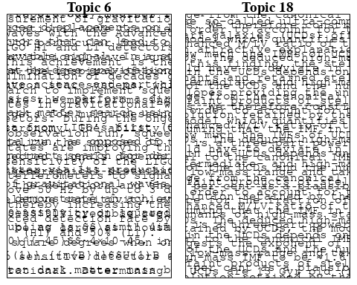

# Calculate and plot the correlation between topics  
mod.out.corr <- topicCorr(Research_topics)  
plot(mod.out.corr, cex = 1.5)  
  
  
# For each topic  
for (topic_num in 1:45) {  
 # Plot the word cloud  
 cloud(Research_topics, topic = topic_num, scale = c(2, 0.25))  
 Sys.sleep(2)  
}

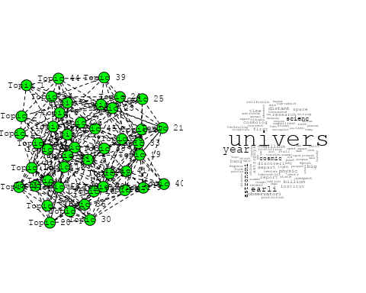

## Warning in wordcloud::wordcloud(words = vocab, freq = vec, max.words =  
## max.words, : physic could not be fit on page. It will not be plotted.

## Warning in wordcloud::wordcloud(words = vocab, freq = vec, max.words =  
## max.words, : review could not be fit on page. It will not be plotted.

## Warning in wordcloud::wordcloud(words = vocab, freq = vec, max.words =  
## max.words, : understand could not be fit on page. It will not be plotted.

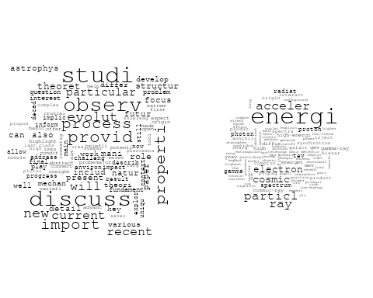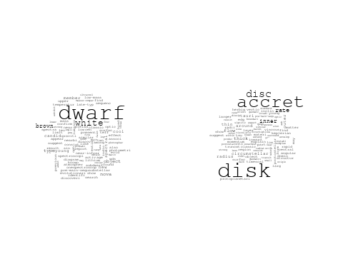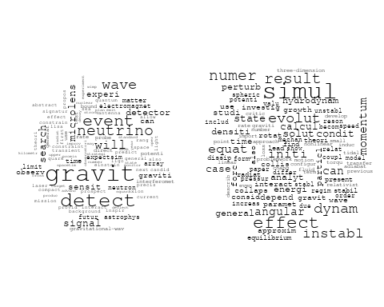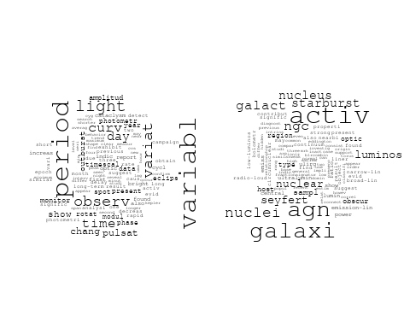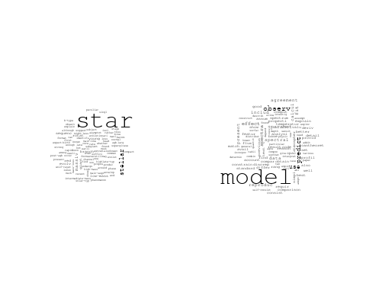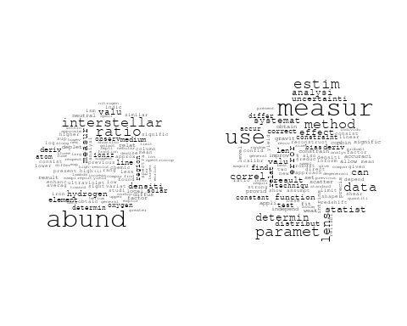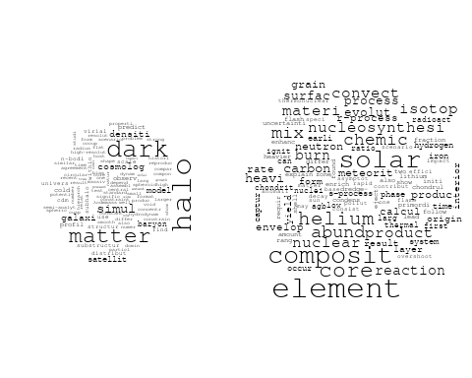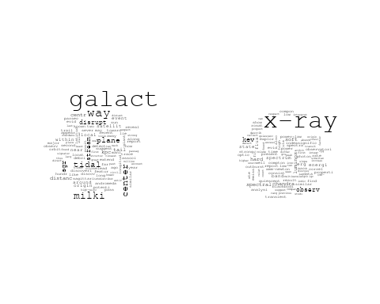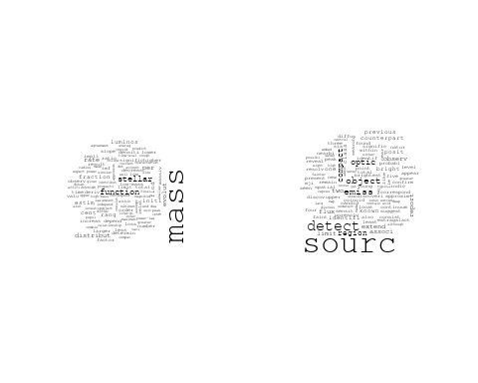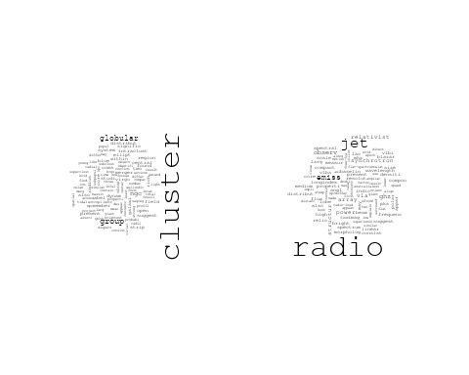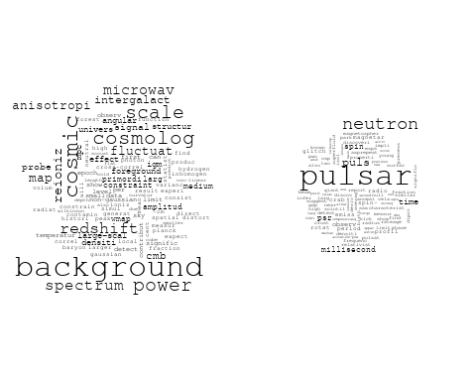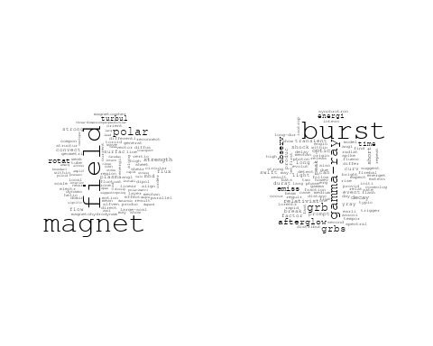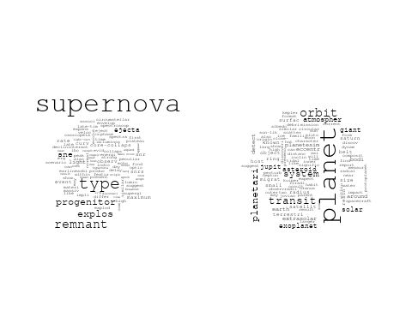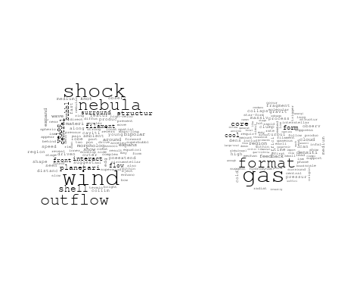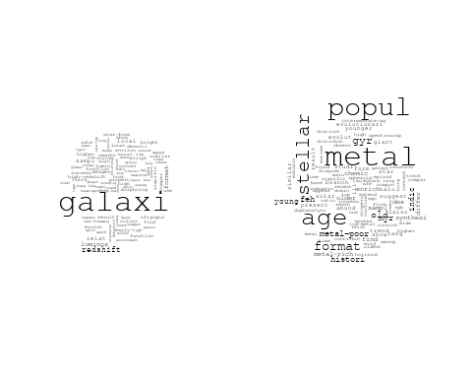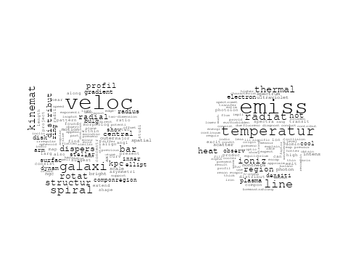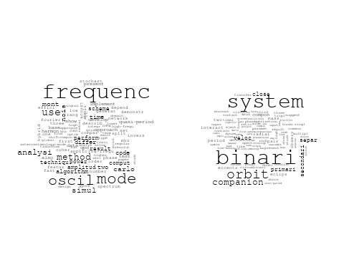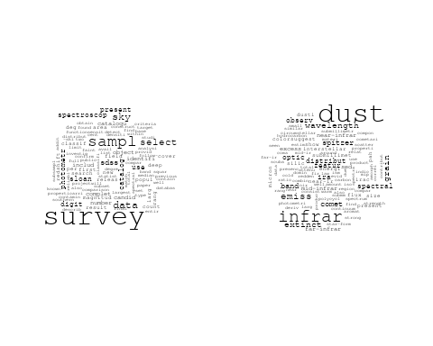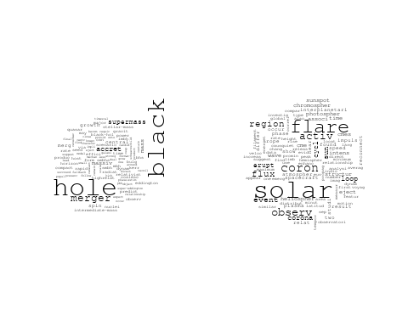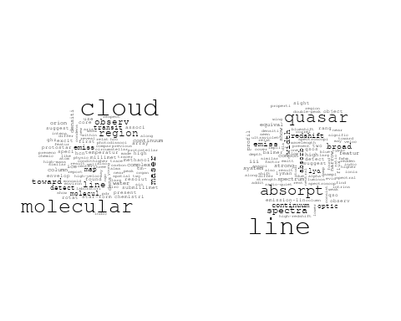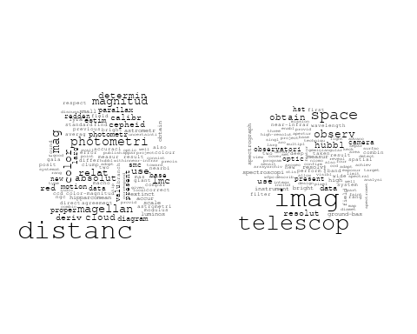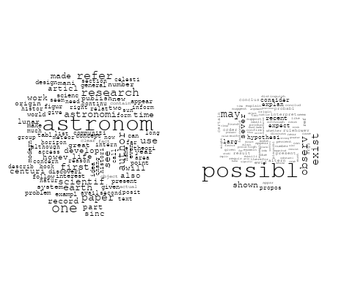

# Get the topic proportions for each document  
topic_proportions <- Research_topics$theta  
  
# Find the index of the topic with the highest proportion for each document  
# This will be the topic that each document is most likely to belong to  
max_topic_idx <- apply(topic_proportions, 1, which.max)  
  
# Add this as a new column to your data  
data$topic <- max_topic_idx  
  
library(ggplot2)  
  
# List of country codes  
countries <- c("US", "GB", "DE", "IT", "AU", "CA", "JP", "CN", "NL", "FR", "RU", "ES", "IN", "IL", "CH", "Americas", "Europe", "Africa", "AsiaAndOceania")  
  
# Create function to generate histogram  
make_histogram <- function(country_code) {  
   
 # Filter data for country with contribution of 100  
 data_100 <- data[data[[country_code]] == 100,]  
   
 # Filter data for country with contribution not equal to 0  
 data_not_0 <- data[data[[country_code]] != 0,]  
   
 # Make the first histogram  
 hist_100 <- ggplot(data_100, aes(x = topic)) +  
 geom_histogram(binwidth = 1, fill = "blue", color = "black") +  
 xlab("Topic") +  
 ylab("Count") +  
 ggtitle(paste(country_code, "Independent Contribution"))  
   
 # Make the second histogram  
 hist_not_0 <- ggplot(data_not_0, aes(x = topic)) +  
 geom_histogram(binwidth = 1, fill = "blue", color = "black") +  
 xlab("Topic") +  
 ylab("Count") +  
 ggtitle(paste(country_code, "Contributions (with collaboration)"))  
   
 # Return list of plots  
 return(list(hist_100, hist_not_0))  
}  
  
# Loop over country codes and generate plots  
for (country in countries) {  
 plots <- make_histogram(country)  
   
 # Print the plots  
 print(plots[[1]])  
 print(plots[[2]])  
}

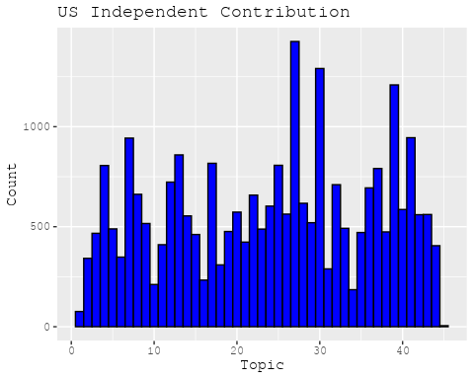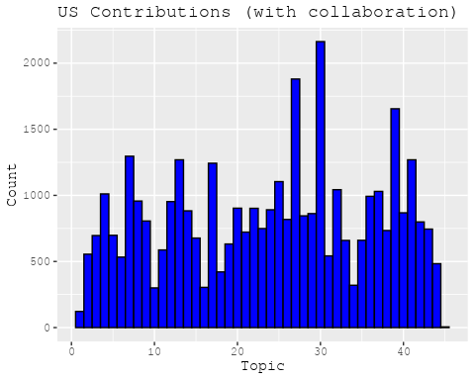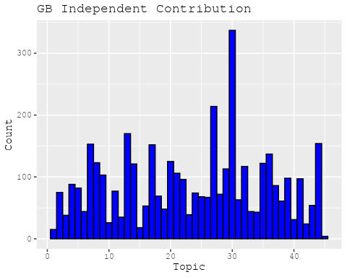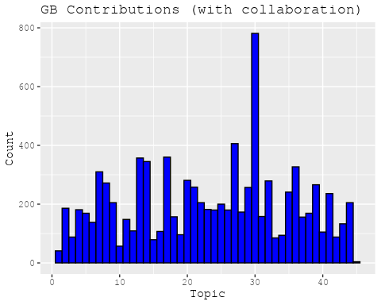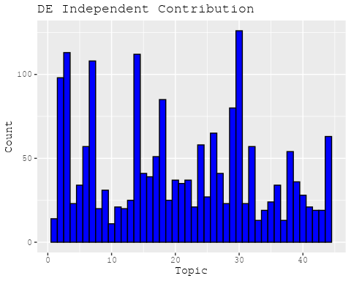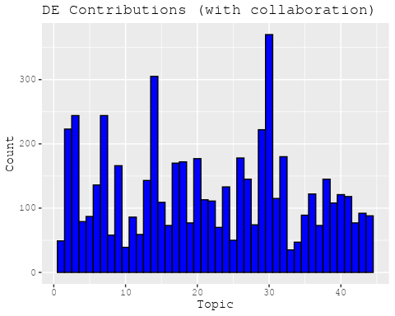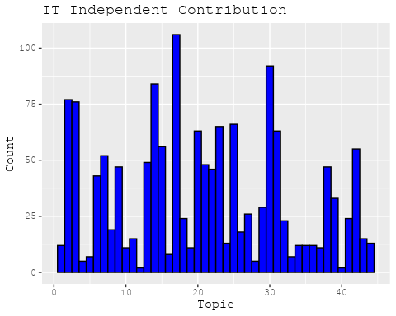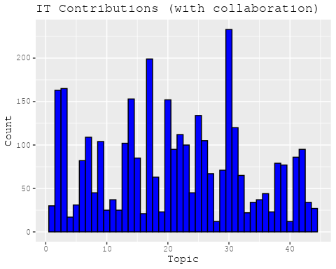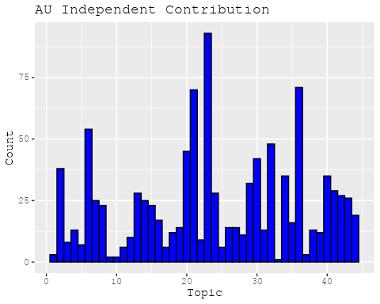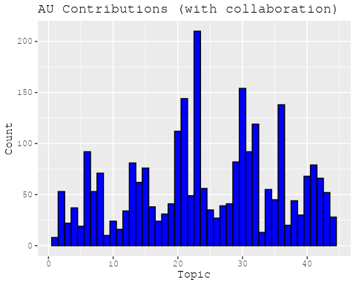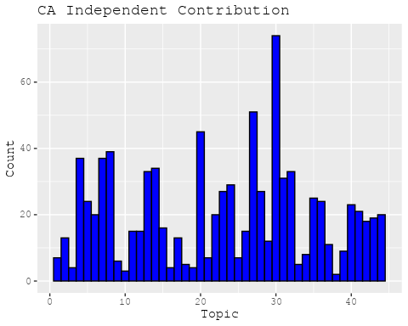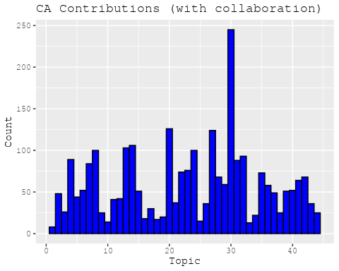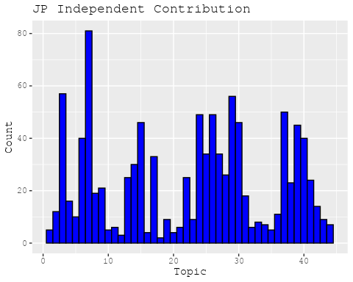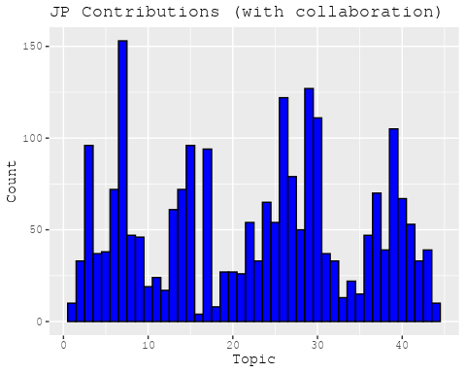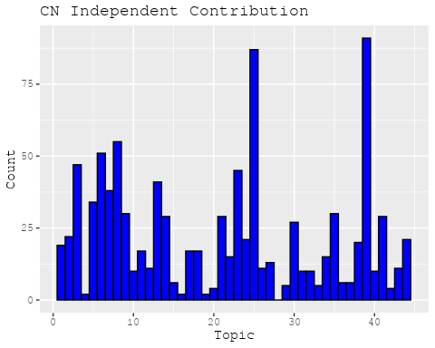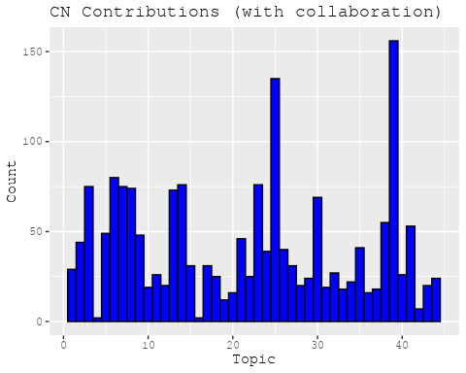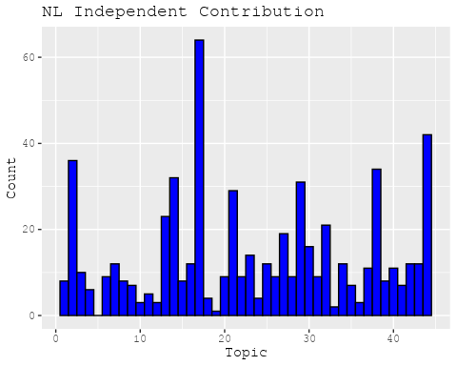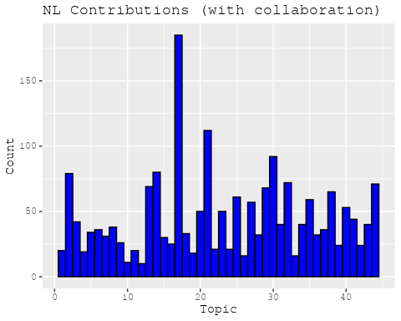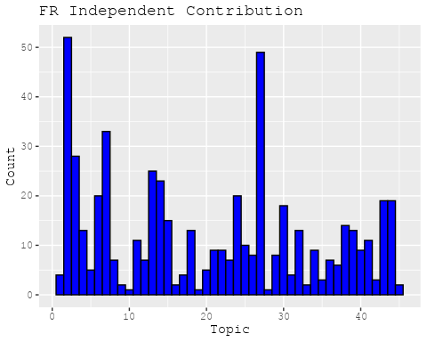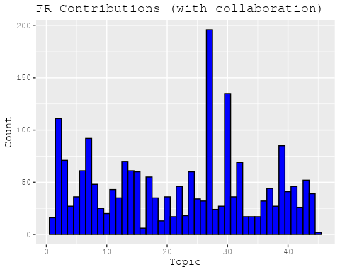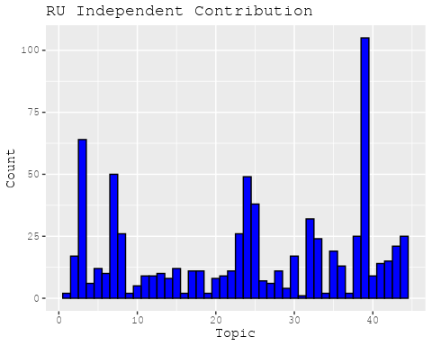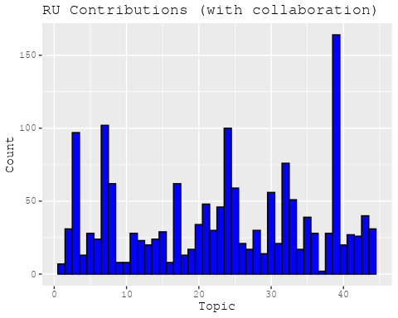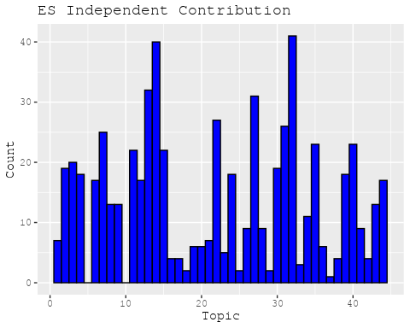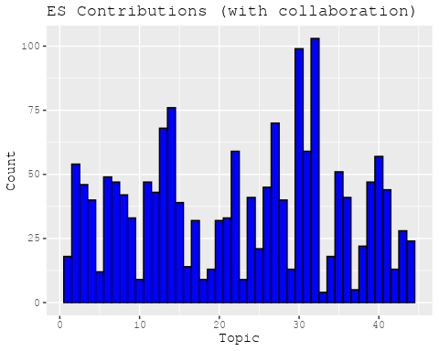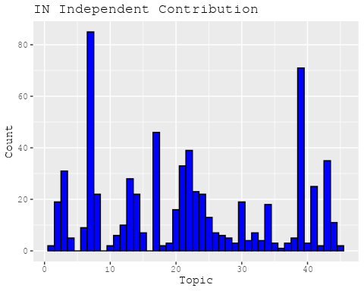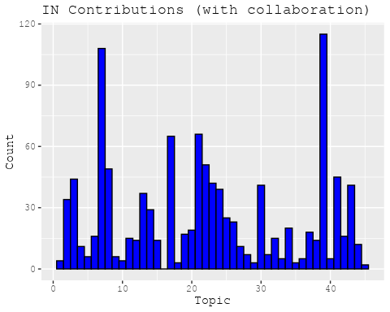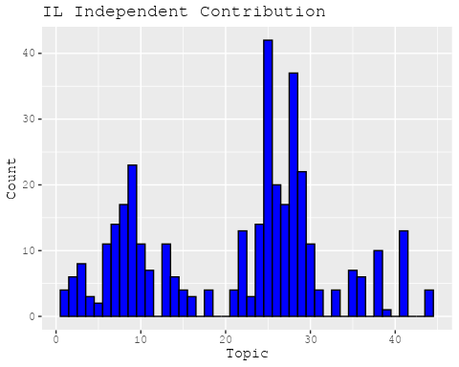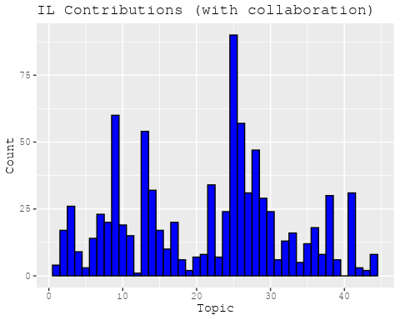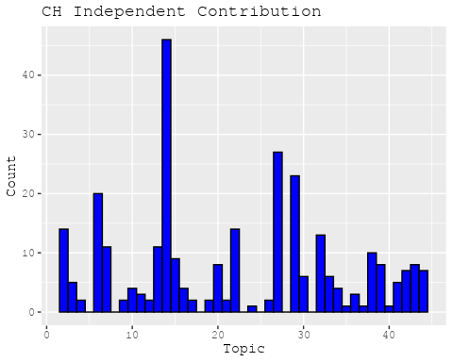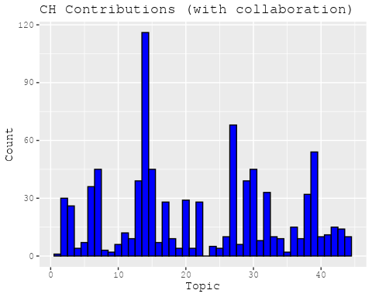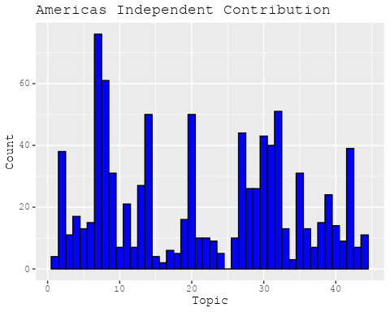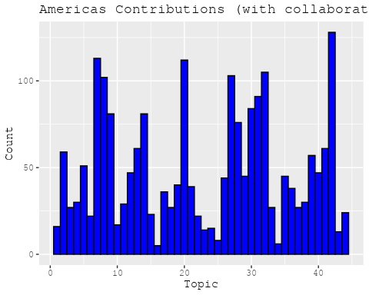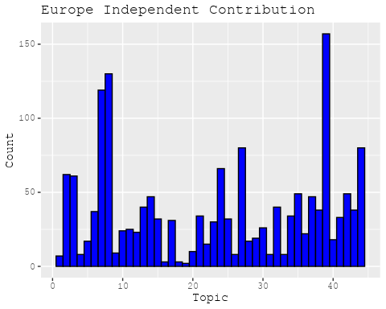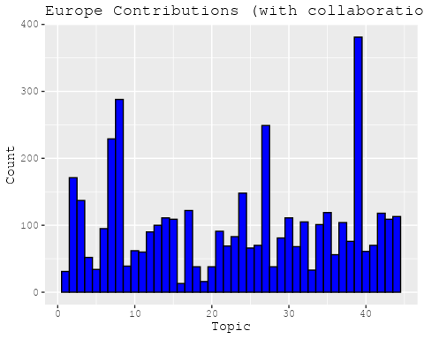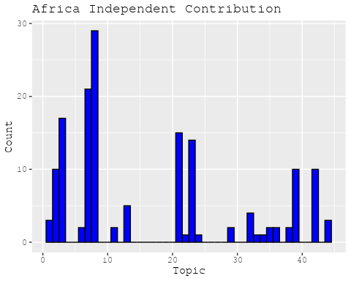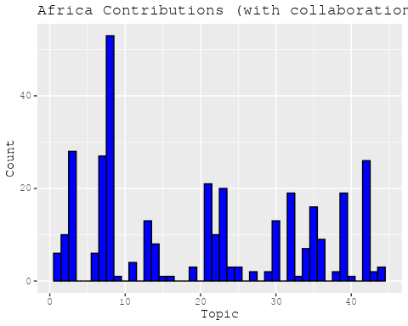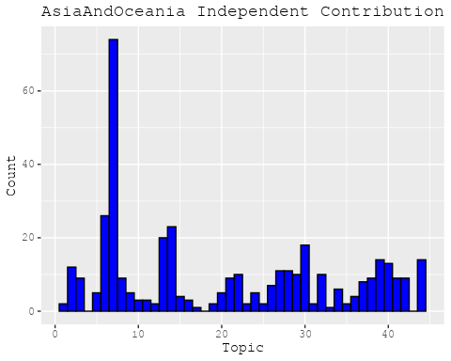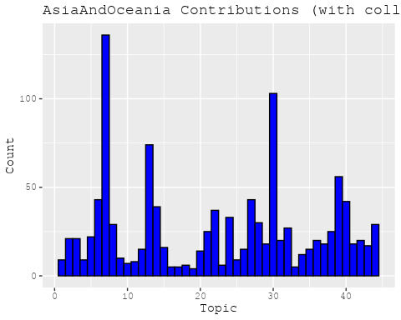

# Define the intervals  
intervals <- c('1824_1899', '1900_1964', '1965_1974', '1975_1984', '1985_1994', '1995_1999', '2000_2004', '2005_2009', '2010_2014', '2015_2019', '2020_2022')  
colors <- c('pink', 'blue', 'purple', 'yellow', 'green', 'pink', 'orange', 'violet', 'green', 'blue', 'pink')  
  
# Loop through the intervals and plot  
for(i in seq_along(intervals)){  
 # Filter data for when the pub_interval is equal to 1  
 data_filtered <- data[data[[paste0('pub_interval_', intervals[i])]] == 1,]  
   
 # Make the histogram  
   
 p <- ggplot(data_filtered, aes(x = topic)) +  
 geom_histogram(binwidth = 1, fill = colors[i], color = "black") +  
 xlab("Topic") +  
 ylab("Count") +  
 ggtitle(paste0("Topics from year ", gsub("_", " to ", intervals[i])))  
   
 print(p)  
}

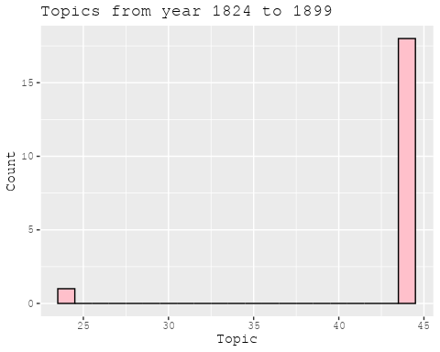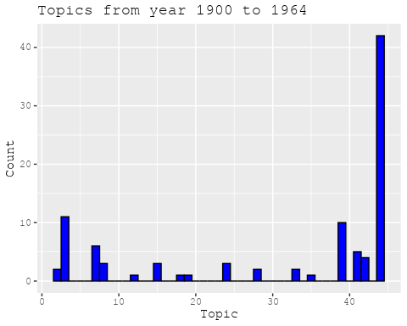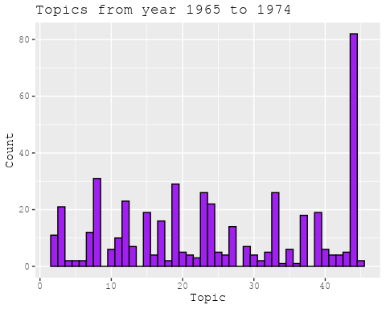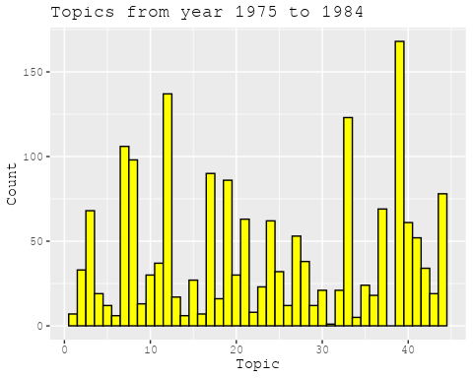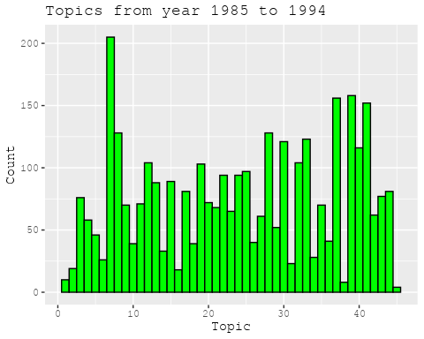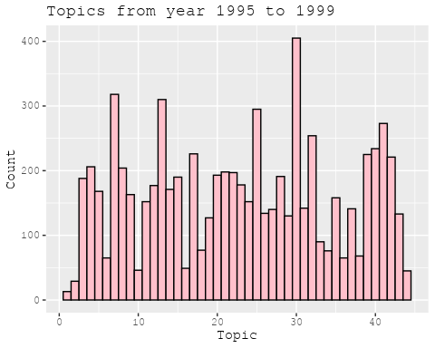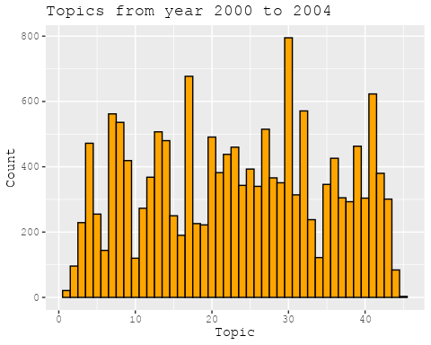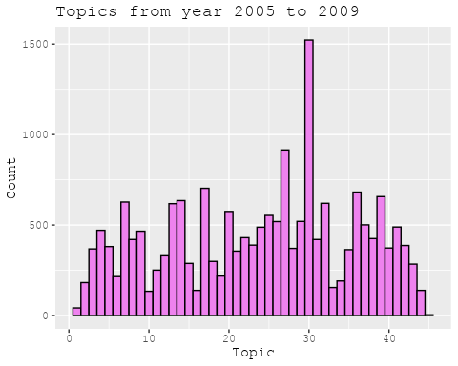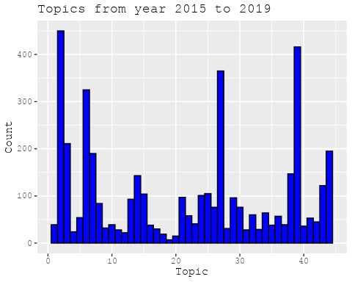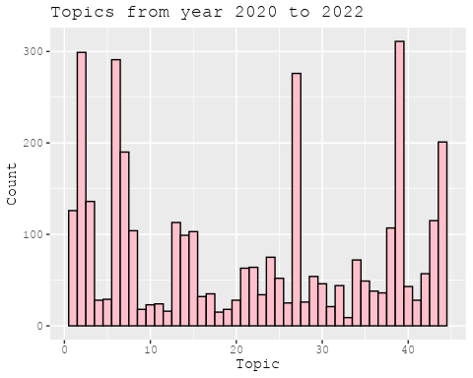

#Kvals <- seq(from = 60, to = 120, by = 5) # K values to try  
#search_results <- searchK(documents = out_text$documents,   
# vocab = out_text$vocab,   
# K = Kvals,   
# prevalence = prevalence_formula,   
# data = out_text$meta,   
# init.type = "Spectral",   
# verbose = FALSE)  
  
#Plot the results  
#plot(search_results)